MITRAIS LEARNING OFFERING
XAML, WPF AND WPF STYLE
ver.1.0

Copyright
Copyright © 2014 Mitrais
All rights reserved.
Confidentiality
This document contains confidential information of Mitrais.
This document can be used and copied within Mitrais for use in relation to this project. However, this document, including copies of it, must not be disclosed to any person who is not a director, officer, employee, consultant or agent of Mitrais without the prior written approval of Mitrais and such person or agent has signed a non-disclosure agreement satisfactory to Mitrais.
Document control
This document is deemed to be controlled only as long as the project to which it relates is active. Controlled copies will be automatically updated. Once the project is completed or terminated, this document will revert to an uncontrolled document status. No further advice will be provided, and each recipient may either destroy the document or mark it as obsolete and retain it for future personal reference. All copies of this document will be issued electronically.
Distribution
Copies of this document will be made available to all Mitrais employee.

Revision History
Date | Version | Description | Author
20-08-2014 | 1.0 | Initial Document | Rory Oktariansyah

Table of Contents
Copyright 2
Copyright © 2014 Mitrais 2
Confidentiality 2
Document control 2
Distribution 2
Revision History 3
Table of Contents 4
Table of Figures 7
1. Background 9
1.1. WPF Architecture 9
1.2. Features of WPF 11
1.3. XAML 12
1.4. Styling and Templating 13
2. Training Goals, Objectives and Coverage 14
2.1. Training Goals 14
2.2. Training Objectives 14
2.3. Training Coverage 14
2.3.1. Use XAML to Create UI Elements 15
2.3.1.1 Create A New WPF Project 15
2.3.1.2 XAML Namespace 16
2.3.1.3 Add a Control to a Window Using XAML 18
2.3.2. Using XAML Attributes to define the Look and Feel of UI Elements 19
2.3.2.1. Inline Attributes 19
2.3.2.2. Explicit Attribute Declaration 19
2.3.3. Using WPF Framework Elements in Applications 20
2.3.3.1. DispatcherObject 21
2.3.3.2. DependencyObject 21
2.3.3.3. Visual 21
2.3.3.4. Visual3D 22
2.3.3.5. UIElement 22
2.3.3.6. FrameworkElement 22
2.3.3.7. Decorator 23
2.3.3.8. Panel 23
2.3.3.9. Shape 23
2.3.3.10. Control 23
2.3.3.11. ContentControl 23
2.3.3.12. ItemsControl 23
2.3.3.13. HeaderedItemsControl 24
2.3.3.14. FrameworkContentElement 24
2.3.3.15. Freezable 24
2.3.3.16. Animatable 24
2.3.4. Declaring, Using, and Debugging Basic WPF Controls Using XAML 24
2.3.4.1. Button 24
2.3.4.2. TextBlock 27
2.3.4.3. Label 29
2.3.4.4. TextBox 30
2.3.4.5. CheckBox 31
2.3.4.6. RadioButton 32
2.3.4.7. DataGrid 33
2.3.5. Declaring, Using, and Debugging Basic WPF Controls Programmatically With Basic Event Handlers Using Control Lifecycle 34
2.3.6. Showing, Hiding, and Focusing on UI Elements 37
2.3.7. Using the Layout System and Layout Controls 37
2.3.7.1. Layout 37
2.3.7.2. Layout Panel Controls 38
2.3.7.3. Margins, Padding, and Alignment 40
2.3.8. Using WPF-Specific Controls 42
2.3.8.1. AccessText 42
2.3.8.2. DocumentViewer 43
2.3.8.3. FlowDocumentReader 45
2.3.9. Styling WPF Controls 47
2.3.9.1. Styling Fundamentals 47
2.3.9.2. Resources 48
2.3.9.3. Static and Dynamic Resources 50
2.3.9.4. Merged Resource Dictionaries 50
2.3.9.5. Styles and Resources 51
2.3.9.6. Control Templates 52
2.3.9.7. Data Template 53
2.3.10. Creating and Using User-Defined Controls 53
2.3.10.1. UserControl 53
2.3.10.2. CustomControl 56
2.3.11. Using Data Binding 60
2.3.11.1. Dependency Properties 60
2.3.11.2. DataContext 61
2.3.11.3. ValueConverters 61
2.3.11.4. Data Binding 62
2.3.12. Using Input Validation and Dialogs 66
2.3.12.1. Input Validation 66
2.3.12.2. Using Dialogs 70
2.3.13. Creating and Using Context Menu 73
3. Training Materials 74

Table of Figures
Figure 1 – WPF Architecture 10
Figure 2 – WPF Styling Example 13
Figure 3 – XAML Basics – New Project Screen 15
Figure 4 – XAML Basics – Newly Created WPF Project Structure 16
Figure 5 – XAML Basics – Rendered Button 19
Figure 6 – WPF Framework Elements – WPF Core Type Inheritance Diagram 21
Figure 7 – Basic Controls – Button Click Event Handler 25
Figure 8 – Basic Controls – Button Application In Debug Mode 26
Figure 9 – Basic Controls – Button Application Changing Color 26
Figure 10 – Basic Controls – Simple TextBox Control 27
Figure 11 – Basic Controls – Clipped TextBox Control 28
Figure 12 – Basic Controls – TextBox Controls With Long Text 29
Figure 13 – Basic Controls – Label Control Example 30
Figure 14 – Basic Controls – TextBox Control Example 31
Figure 15 – Basic Controls – CheckBox Control Example 32
Figure 16 – Basic Controls – RadioButton Control Example 33
Figure 17 – Basic Controls – DataGrid Control Example 34
Figure 18 – Basic Controls – In-code Button Example 35
Figure 19 – Basic Controls – In-code Button Clicked Example 36
Figure 20 – Layout – Alignment, Margin and Padding Sample 41
Figure 21 – Layout – Alignment, Margin and Padding Detailed Diagram 41
Figure 22 – Layout – Alignment, Margin and Padding Sample Application 42
Figure 23 – WPF-Specific Controls – AccessText Sample Application 43
Figure 24 – WPF-Specific Controls – Add Project Reference Screen 44
Figure 25 – WPF-Specific Controls – DocumentViewer Application Sample 45
Figure 26 – WPF-Specific Controls – FlowDocumentViewer Application Sample 46
Figure 27 – WPF Styling – Button Design Sample 47
Figure 28 – User-Defined Controls – Add User Control Screen 54
Figure 29 – User-Defined Controls – User Control Example 56
Figure 30 – User-Defined Controls – Custom Control Library Project Screen 57
Figure 31 – User-Defined Controls – Custom Control Library Project Structure 57
Figure 32 – User-Defined Controls – Add Reference Screen 59
Figure 33 – Data Binding – Data Binding Example 64
Figure 34 – Data Binding – Formatting Displayed Data Using Resources Example 64
Figure 35 – Data Binding – Binding Directions 65
Figure 36 – Input Validation – Initial Screen 69
Figure 37 – Input Validation – Validation Message 70
Figure 38 – Input Validation – Validation Dialog Message 72
Figure 39 – Input Validation – Confirmation Dialog Message 73
Figure 40 – Context Menu – TextBox With Context Menu 74

- Background
The Windows Presentation Foundation (WPF) is Microsoft’s next generation UI framework that provides developers with a unified programming model for building rich Windows smart client user experiences incorporating UI, media, and documents.
The core of WPF is a resolution-independent and vector-based rendering engine that is built to take advantage of modern graphics hardware. WPF extends the core with application-development features including Extensible Application Markup Language (XAML), controls, data binding, layout, 2-D and 3-D graphics, animation, styles, templates, documents, media, text, and typography.
The WPF is part of the .NET framework 3.0 and higher. That means you can use WPF technology in Visual Studio 2008. WPF’s emphasis on vector graphics allows most controls and elements to be scaled without loss in quality, increasing accessibility.
A powerful concept in WPF is the logical separation of a control from its appearance: a control template can be overridden to completely change its visual appearance, and a control can contain any other control or layout, allowing for a high degree of control over composition.
  - WPF Architecture
WPF architecture is a layered architecture which have Managed, Unmanaged and Core API layers as shown below.

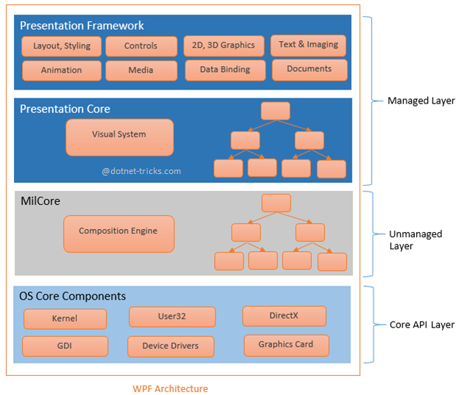
Figure 1 – WPF Architecture

- Managed Layer
Managed layer has two main components: Presentation Framework and Presentation Core.
Presentation Framework provides the required functionalities that we need to build the WPF applications such as controls, data bindings, styling, shapes, media, documents, annotations, animation and more. PresentationFramework.dll is responsible for this purpose.
Presentation Core acts as a managed wrapper around MILCore and provides public interface for MIL. Presentation Core is the home for WPF Visual System and provides classes for creating application visual tree. The Visual System creates visual tree which contains applications Visual Elements and rendering instructions. PresentationCore.dll is responsible for this purpose.
- Unmanaged Layer
This layer is also called MILCore or Media Integration Library Core. MILCore is written in unmanaged code in order to enable tight integration with DirectX. DirectX engine is underlying technology used in WPF to display all graphics, allowing for efficient hardware and software rendering. MIL has Composition System that receives rendering instructions from Visual System and translates into data that can be understood by DirectX to render user interface.
- Core API Layer
This layer has OS core components like Kernel, User32, GDI, Device Drivers, Graphic cards etc. These components are used by the application to access low level APIs. User32 manages memory and process separation.
  - Features of WPF
- Direct3D
Graphics, including desktop items like windows, are rendered using Direct3D. This allows the display of more complex graphics and custom themes, and offloads some graphics tasks to the GPU, reducing the workload on the computer’s CPU.
- Data binding
WPF has a built-in set of data services to enable application developers to bind and manipulate data with applications. It supports four types of data binding:
- One-time, where the client ignores updates on the server.
- One-way, where the client has read-only access to data.
- Two-way, where client can read from and write data to the server.
- One-way-to-source, where the client has write-only access to data.
LINQ queries, including LINQ to XML, can also act as data sources for data binding. Binding of data does not affect its presentation. Presentation of data is controlled using data templates.
- Media services
The WPF provides an integrated system for building user interfaces with common media elements like vector and raster images, audio, and video. WPF also provides an animation system and a 2D/3D rendering system.
- Templates
In WPF, you can define the look of an element directly, via its properties, or indirectly using a Template or Style. A style is a combination of property settings that can be applied to a UI template with a single property attribute. Templates are a mechanism for defining alternate UI for an element. Several templates types are available in WPF such as ControlTemplate, DataTemplate etc.
- Animations
WPF supports time-based animations in contrast to the frame-based approach. This decouples the speed of the animation from the performance of the system.
- Imaging
WPF can natively access Windows Imaging Component (WIC) code and APIs allowing developers to write image codecs for their specific image file formats.
- Documents
WPF natively supports paginated documents using the DocumentViewer and FlowDocumentReader classes.
- Text
WPF includes a number of text rendering feature that were not available in GDI, supporting OpenType, TrueType, and OpenType CFF (Compact Font Format) fonts.
- Interoperability
UI elements from Windows Forms can also be used using ElementHost and WindowsFormHost classes.
- Alternative Input
WPF supports digital ink-related functionality and multi-touch input on WPF 4.0 and higher.
- Accessibility
WPF supports Microsoft UI Automation to allow developers to create accessible interfaces, and allows automated test scripts to interact with the UI.
  - XAML
Following the success of markup languages for web development, WPF introduces eXtensible Application Markup Language (XAML), which is based on XML. While XML is a markup language, XAML is designed as a more efficient method of developing application user interfaces: a declarative application markup language.
When represented as text, XAML files are XML files that generally have the .xaml extension. The files can be encoded by any XML encoding, but encoding as UTF-8 is typical.
The specific advantage that XAML brings to WPF is that XAML is a completely declarative language, allowing the developer (or designer) to describe the behavior and integration of components without the use of procedural programming. Although it is rare that an entire application will be built completely in XAML, the introduction of XAML allows application designers to more effectively contribute to the application development cycle. Using XAML to develop user interfaces also allows for separation of model and view, which is considered a good architectural principle. In XAML, elements and attributes map to classes and properties in the underlying APIs. Other advantages of using XAML instead of in-code:
- XAML code is shorter and clearer to read.
- Clear separation of designer role (UI design) and developer (code and logic).
- Graphical design tools like Expression Blend require XAML as their source.
As in web development, both layouts and specific themes are well suited to markup, but XAML is not required for either. Indeed, all elements of WPF may be coded in a .NET language (C#, VB.NET). The XAML code can ultimately be compiled into a managed assembly in the same way all .NET languages are.
  - Styling and Templating
WPF introduces styling, which is to XAML what CSS is to HTML. It refers to a suite of features, including triggers and storyboards. The suite allows developers and designers to create visually compelling effects and to create a consistent appearance for their product. Although developers and/or designers can customize the appearance extensively on application-by-application basis, a strong styling model is necessary to allow maintenance and sharing of the appearance within and among applications. WPF provides that model.
Another feature of the WPF styling model is the separation of presentation and logic. This means that designers can work on the appearance of an application by using only XAML at the same time that developers work on the programming logic by using C# or Visual Basic.
Using styles, you can group a set of properties and assign them to specific controls or all controls of a specific type, and just like in CSS, a style can inherit from another style.

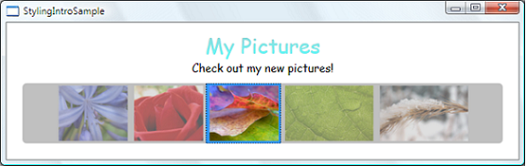
Figure 2 – WPF Styling Example

The look and feel of the WPF UI elements can also be defined using Templates. It is closer in nature to XBL (XML Binding Language), an XML-based markup language used to declare the behavior and look of XML elements.
Every predefined control in the WPF that has a visual appearance also has a template that entirely defines the appearance. This template is an object of type ControlTemplate that is set to the Template property defined by the control class.
When you use a WPF control in your application, you can replace that default template with one of your own design. You retain the basic functionality of the control, including all the keyboard and mouse handling, but you can give it an entirely different look.
- Training Goals, Objectives and Coverage

  - Training Goals
The goals of this training are to gain an understanding of the Windows Presentation Foundation (WPF), the underlying XAML technology, and WPF styling.
  - Training Objectives
The objective of the training is so that by the end of the training, trainees could do the following:
- Use XAML to create user interface (UI) elements.
- Use XAML attributes to define the look and feel of UI elements.
- Effectively use WPF framework elements in applications.
- Declare, use, and debug basic WPF controls using XAML.
- Create and implement event handlers to WPF controls.
- Declare, use, and debug basic WPF controls programmatically.
- Understand the lifecycle of a control (including a window).
- Show, hide, and focus on UI elements.
- Understand layout controls and their uses in applications.
- Understand how to use layout features such as margins, paddings and alignment.
- Use WPF-specific controls such as AccessText and DocumentViewer
- Understand the concept of styling and use style elements within applications.
- Use user-defined controls and implement event handlers to user-defined controls.
- Understand data binding and use it within applications.
- Use input validation and dialog boxes.
- Create and use context menus.
  - Training Coverage
For the steps in this training manual, the environment that will be used consists of:
- Windows 7.
- Standard Operating Environment as of 01 August 2014.
- Visual Studio 2012.
- .NET 4.5
It will be assumed that you have installed Windows 7, and the needed tool Visual Studio 2012 has been installed and properly configured. As WPF is part of the .NET framework 3.0 and higher, the source code attached to this document can also be run in Visual Studio 2008.
    - Use XAML to Create UI Elements
Much of the material in this section will be familiar if you have previous exposure with the XML language. This is a consequence of one of the basic design principles of XAML. The XAML language defines concepts of its own, but these concepts work within the XML language and markup form.
      - Create A New WPF Project
To create a new WPF project, follow these steps:
- Open Visual Studio 2012.
- From the start screen, select New Project.
- Select Installed > Templates > Visual C# > Windows node on the New Project screen.
- Select WPF Application from the node children.
- Select the folder to save the project. In this lesson, D:\WPF Training\ is used.
- Type in the name of the project. In this lesson, XAMLBasics is used.
- Make sure that the Create directory for solution checkbox is checked. We will need this to separate the solutions used across the lessons in this training.

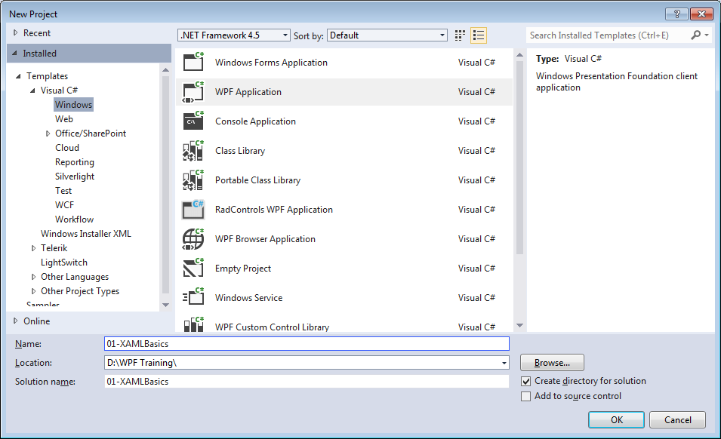
Figure 3 – XAML Basics – New Project Screen

- You should be presented with the following screen:
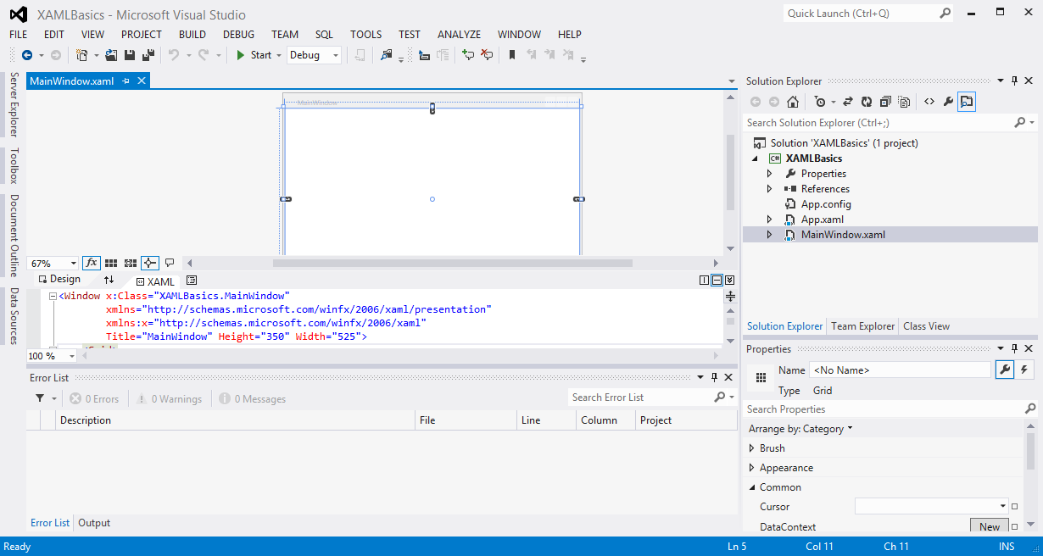
Figure 4 – XAML Basics – Newly Created WPF Project Structure

Please focus your attention to the XAML tab. It will show skeletal design markup for the MainWindow class. The code that you are looking at is the XAML language, an XML-based language specifically used by WPF. Every tag can represent either an object or a property not defined within the main tag.

<Window x:Class="XAMLBasics.MainWindow"
xmlns="http://schemas.microsoft.com/winfx/2006/xaml/presentation"
xmlns:x="http://schemas.microsoft.com/winfx/2006/xaml"
Title="MainWindow" Height="350" Width="525">
<Grid>

</Grid>
</Window>

What the above block of code does is creates a window, and places a grid layout control in the window.
      - XAML Namespace
Note the 2 xmlns… lines from the above code block. Those are the default namespace declarations for new XAML files.
XAML namespace is an extension of the concept of an XML namespace. The techniques of specifying a XAML namespace rely on the XML namespace syntax, the convention of using URIs as namespace identifiers, using prefixes to provide a means to reference multiple namespaces from the same markup source, and so on. The primary concept that is added to the XAML definition of the XML namespace is that a XAML namespace implies both a scope of uniqueness for the markup usages, and also influences how markup entities are potentially backed by specific CLR namespaces and referenced assemblies. For the purposes of how WPF works with XAML namespaces, you can generally think of XAML namespaces in terms of a default XAML namespace, the XAML language namespace, and any further XAML namespaces as mapped by your XAML markup directly to specific backing CLR namespaces and referenced assemblies.
Within the namespace declarations in the root tag of many XAML files, you will see that there are typically two XML namespace declarations. The first declaration maps the overall WPF client/framework XAML namespace as the default:

xmlns="http://schemas.microsoft.com/winfx/2006/xaml/presentation"

The second declaration maps a separate XAML namespace, mapping (aliasing) it (typically) to the x: prefix.

xmlns:x="http://schemas.microsoft.com/winfx/2006/xaml"

The relationship between these declarations is that the x: prefix mapping supports the intrinsic that are part of the XAML language definition, and WPF is one implementation that uses XAML as a language and defines a vocabulary of its objects for XAML. Because the WPF vocabulary’s usages will be far more common than the XAML intrinsic usages, the WPF vocabulary is mapped as the default.
The XAML namespace defines many commonly-used feature that are necessary even for basic WPF applications.
You can map XML namespaces to assemblies using a series of tokens within an xmlns prefix declaration, similar to how the standard WPF and XAML-intrinsics XAML namespaces are mapped to prefixes.
The syntax takes the following possible named tokens and following values:
- clr-namespace: The CLR namespace declared within the assembly that contains the public types to expose as elements.
- Assembly= The assembly that contains some or all of the referenced CLR namespace. This value is typically just the name of the assembly, not the path, and does not include the extension (such as .dll or .exe). The path to that assembly must be established as a project reference in the project file that contains the XAML you are trying to map. In order to incorporate versioning and strong-name signing, the assembly value can be a string as defined by AssemblyName, rather than the simple string name.
Note that the characted separating the clr-namespace token from its value is a colon (:) whereas the characted separating the assembly token from its value is an equal sign (=). The character to use between these two tokens is a semicolon. Also, do not include whitespace anywhere in the declaration.
To put it all together, the following is XAML that includes the custom alias along with the typical default and x: mappings in the root tag, then uses a prefixed reference to instantiate ExampleClass in that UI:

<Window x:Class="XAMLBasics.MainWindow"
xmlns="http://schemas.microsoft.com/winfx/2006/xaml/presentation"
xmlns:x="http://schemas.microsoft.com/winfx/2006/xaml"
xmlns:custom="clr-namespace:SDKSample;assembly=SDKSampleLibrary"
Title="MainWindow" Height="350" Width="525">
<Grid>
<custom:ExampleClass/>
</Grid>
</Window>

      - Add a Control to a Window Using XAML
Now we are going to add an object of the button class using XAML.
- Try to add this code inside the <Grid> block:

<Grid>
<Button></Button>
</Grid>

This code does not actually create a button on screen. We will have to specify some other stuff to get this on screen in the rendered design window. Please note that there is no variable name associated with the new button object. In XAML, we set an object’s Name property for the object to have a name.
- Change the button code block to this:

<Button Name="myButton"></Button>

This new button object is now accessible via the code by referencing its name.
- Fill in the gap between the start and end tag with a text.

<Button Name="myButton">Mitrais Certification Program</Button>

- We can now see that the button has now been rendered in the Design pane.

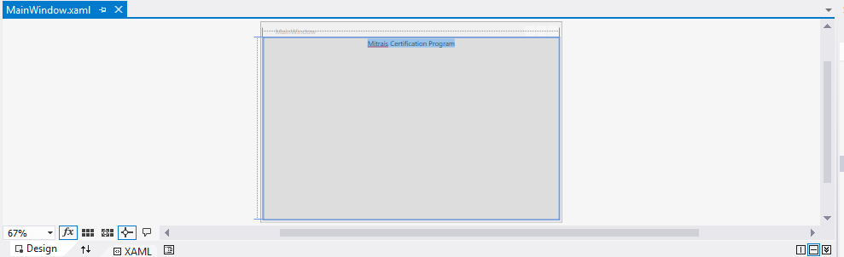
Figure 5 – XAML Basics – Rendered Button

However, the button cannot do anything at this time.
- Save your work using File > Save All menu item.

    - Using XAML Attributes to define the Look and Feel of UI Elements
      - Inline Attributes
Properties of an object can often be expressed as attributes of the object element. Attribute syntax names the property that is being sent in attribute syntax, followed by the assignment operator (=). The value of an attribute is always specified as a string that is contained within the quotation marks.
Attribute syntax is the most streamlined property setting syntax and is the most intuitive to use for developers who have used markup languages in the past. The following markup creates a button that has a red text and a blue background.
<Button Name="myButton" Background="Blue" Foreground="Red">Mitrais Certification Program</Button>
The above declaration is called inline declaration. It is a very intuitive declaration of simple attributes (Name, Background, and Foreground attributes corresponding to the same properties of the Button object).
      - Explicit Attribute Declaration
For some properties of an object element, inline attribute syntax is not possible, because the object or information necessary to provide the property value cannot be adequately expressed within the quotation mark and string string restrictions of inline attribute syntax. For these cases, a different syntax known as property element syntax, or explicit attribute declaration, can be used.
The syntax for the property element tag is <typeName.propertyName>. Generally, the content of that tag is an object element of the type that the property takes as its value. After specifying content, you must close the property element with an end tag. The syntax for the end tag is </typeName.propertyName>.
While attribute syntax is possible, using the attribute syntax is typically more convenient and enables a more compact markup, but that is often just a matter of style, not a technical limitation. The following example shows the same properties being set as in the previous attribute syntax example, but this time by using property element syntax for all properties of the Button.

<Button>
Mitrais Certification Program
<Button.Name>
myButton
</Button.Name>
<Button.Background>
<SolidColorBrush Color="Blue"/>
</Button.Background>
<Button.Foreground>
<SolidColorBrush Color="Red"/>
</Button.Foreground>
</Button>

Please note that compared to the explicit declaration, Background="Blue" is also called abbreviated (shortened) markup declaration, because the SolidColorBrush tag is already included in the attribute declaration.
    - Using WPF Framework Elements in Applications
Each XAML file that we create has exactly one root element, which is the top-level parent element of the file. In WPF, the root element is typically one of:
- <Page> – a page of content that can be hosted in a browser (System.Windows.Controls.Page).
- <Window> – a WPF Window (System.Windows.Window).
- <Application> – a WPF Application (System.Windows.Application).
- <ResourceDictionary> – a collection of resources (System.Windows.ResourceDictionary)
- <UserControl> – a user-defined control (System.Windows.Controls.UserControl).
Root elements also typically include attributes that indicate the namespace(s) used to interpret the content of the XAML file.
The WPF core architecture has many types that can be used in applications. This section will briefly talk about the visual elements that we can use in our applications. Details for the classes will be discussed in the next chapters. The WPF core type inheritance diagram can be seen below.

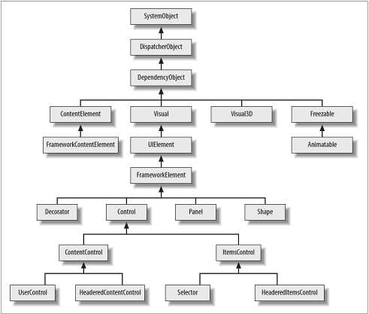
Figure 6 – WPF Framework Elements – WPF Core Type Inheritance Diagram

      - DispatcherObject
DispatcherObject is the base class of any type associated with a Dispatcher. The dispatcher mechanism is WPF’s message processing system. It underpins critical services including input handling, and certain aspects of layout and data binding. It is also at the heart of WPF threading model.
      - DependencyObject
Classes derive from DependencyObject to employ WPF’s dependency property system. By handling control of a property to the dependency property system, we can take advantage of data binding, styling, animation, property value inheritance, default values, per-type metadata, and property change notifications.
      - Visual
The Visual class is the abstract base class of all 2D elements. It provides rendering services, as well as transformation and hit testing support. This class is not an extensibility point, we cannot usefully derive our own classes from it. We must inherit from UIElement to exploit the rendering services.
      - Visual3D
Visual3D class fulfills the same role for 3D content as Visual does in 2D. All 3D elements derive from Visual3D, which provides transformation and hit testing services.
      - UIElement
Layout is a core concept in WPF. In many systems there is either a fixed set of layout models (HTML supports three models for layout; flow, absolute, and tables) or no model for layout (User32 really only supports absolute positioning). WPF started with the assumption that developers and designers wanted a flexible, extensible layout model, which could be driven by property values rather than imperative logic. UIElement class defines core subsystems including Layout, Input, and Events. At the UIElement level, the basic contract for layout is introduced – a two phase model with Measure and Arrange passes.
Measure allows a component to determine how much size it would like to take. This is a separate phase from Arrange because there are many situations where a parent element will ask a child to measure several times to determine its optimal position and size. The fact that parent elements ask child elements to measure demonstrates another key philosophy of WPF – size to content. All controls in WPF support the ability to size to the natural size of their content. This makes localization much easier, and allows for dynamic layout of elements as things resize. The Arrange phase allows a parent to position and determine the final size of each child.
UIElement also introduces the notion of CommandBindings. The WPF command system allows developers to define functionality in terms of a command end point. Command bindings enable an element to define a mapping between an input gesture (e.g. Ctrl+N) to a command (e.g. New). Both the input gestures and command definitions are extensible, and can be wired together at usage time. This makes it trivial, for example, to allow an end user to customize the key bindings that they want to use within an application.
      - FrameworkElement
FrameworkElement is the base class of the majority of visible elements in WPF. It derives from UIElement, so types that derive from FrameworkElement are able to render their own appearance and respond to user input. FrameworkElement adds data binding, styling, and resource handling, and it builds the full set of layout and animation services on top of the primitive services provided by UIElement.
FrameworkElement also provides a great deal of infrastructure for data templates and control templates.
      - Decorator
Decorator is the base class for elements that contain a single child. For example, Border adds an outline and optional padding around an element. ViewBox scales its child to fit the space available. InkPresenter enables ink rendering on its child.
      - Panel
Panel is the abstract base class of elements that contain and arrange multiple child elements. Each derive type implements a particular layout strategy. For example, StackPanel arranges items in a single column or row.
      - Shape
Shape is the abstract base class of graphical shape elements that can be added to the UI. The derived types include Rectangle, Ellipse, and Path. WPF defines two sets of classes for working with graphical shapes: those derived from Shape and another set derived from Geometry. The distinction is that Shape-based elements derive from FrameworkElement and therefore can use data binding, handle input, raise events, employ styles and participate in layout.
      - Control
Control is the base class for elements that offer a particular interactive behavior. For example, a TextBox allows the user to enter and edit text, a ListBox presents a list of items, allowing the user to scroll through and select items.
Not all visual elements derive from Control. Elements with no intrinsic interactive behavior derive directly from FrameworkElement of from one of the other non-control base classes.
Control defines a Template property. This contains a reference to a ControlTemplate that defines the appearance of the ontrol.
      - ContentControl
ContentControl is a specialized type of Control. It is the base class for any control that can host a single content, which goes in the Content property. The content can be plain text or a tree of user interface elements (e.g. a nested control, or a panel containing several child items). The content can also be any .NET object, in which case WPF will attempt to display it using a data template.
      - ItemsControl
ItemsControl is the base class for all controls that present lists or trees of items, including ListBox, TreeView and Menu. Because it is a concrete class, it can also be used in its own right. ItemsControl provides item presentation and data binding support, but does not offer item selection; this lets you present a list of items without being forced to make them selectable.
      - HeaderedItemsControl
HeaderedItemsControl derives from ItemsControl, so it does everything that Control does, but it also adds a Header property designed to hold a single item of content. This works in the same way as the Content property of ContentControl.
      - FrameworkContentElement
FrameworkContentElement is the base class of all types in WPF’s text object model. Because this class does not derive from Visual, elements of this type do not generate their own appearance. Instead, a tree of content elements is merely a description of some textual content, and it requires some elements derived from Visual to present the content. WPF provides four such elements. TextBlock presents simple textual content, whereas the three flow document readers: FlowDocumentScrollViewer, FlowDocumentPageViewer, and FlowDocumentReader, present larger bodies of text.
      - Freezable
Many types in WPF describe features of the user interface rather than being UI elements in their own right. For example, the various brush types describe how a particular UI feature should be colored; geometries describe shapes of graphical elements. Most of these descriptive classes derive from the common Freezable class; it is an important class in the WPF class hierarchy because so many important types derive from it.
      - Animatable
Many of the Freezable types describe aspects of an element’s appearance such as its shape or color, which make them candidates for animation. Most Freezable types therefore derive from Freezable indirectly through the Animatable class. This class provides WPF’s animation system with the hooks it needs to change properties over time.
    - Declaring, Using, and Debugging Basic WPF Controls Using XAML
Continuing from section 2.3.2, we will try to use some basic WPF controls using XAML and some code-behind. Not all WPF controls will be discussed in this section. Trainees are encouraged to explore other WPF controls.
      - Button
Buttons are the most commonly used control in WPF applications. To start this section:
- Create a new WPF project.
- In MainWindow.xaml file, add this block of code:

<Button Name="myButton" Background="Green"
BorderBrush="Black" BorderThickness="1"
Click="myButton_Click" ClickMode="Press">
Mitrais Certification Program
</Button>

- Right-click on the "myButton_Click" value and select Navigate to Event Handler to get to the code-behind and the event handler. We will discuss about this event handler in the next section.

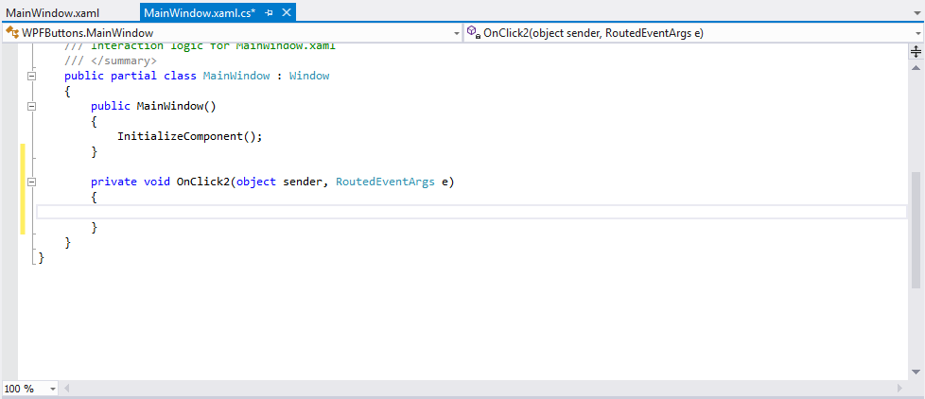
Figure 7 – Basic Controls – Button Click Event Handler

- Add the code block below to the event handler:

private void myButton_Click(object sender, RoutedEventArgs e)
{
myButton.Background = Brushes.Red;
}

- Save your work using File > Save All menu item.
- Run the application by pressing F5 button.
- This will get you to the debug mode of you application. In debug mode, you can see the debug messages and exceptions in details that will help you to improve the quality of your application. You should see the below screen.

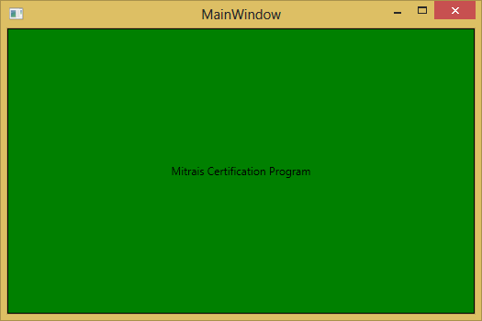
Figure 8 – Basic Controls – Button Application In Debug Mode

- Try clicking the button. You should see the button’s color changed to red.

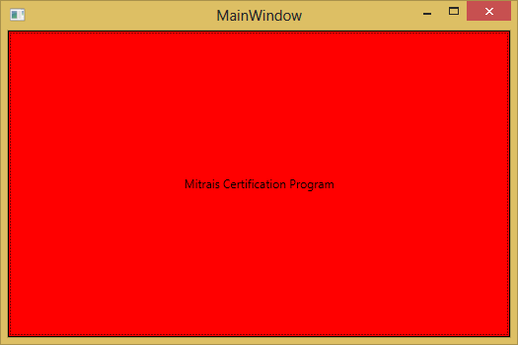
Figure 9 – Basic Controls – Button Application Changing Color

- Go to the Visual Studio window and press Shift-F5 to stop debugging the application.
- Change ClickMode="Press" to ClickMode="Hover" and save your work again.
- Try to debug the application again and see that the button changes its color whenever you move your mouse pointer over it.
- Change ClickMode="Press" to ClickMode="Release" and save your work again.
- Try to debug the application again and see that the button changes its color when you release the mouse left button, instead of when clicking on the button.
      - TextBlock
The TextBlock control is one of the most fundamental controls in WPF, but very useful. It allows you to put text on the screen, much like a Label control does, but in a simpler and less resource demanding way. A common understanding is that a label is for short, one-line texts (but may include e.g. an image), while the TextBlock works very well for multiline strings as well, but can only contain text (strings). To start this section:
- Create a new project and insert this code block to the Grid block:

<TextBlock>
Mitrais Certification Program
</TextBlock>

- Save and run the application.
- You should see the below screen.

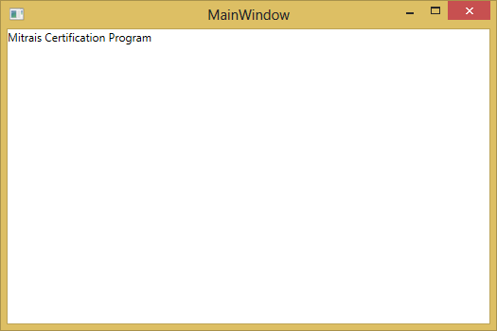
Figure 10 – Basic Controls – Simple TextBox Control

- Stop debugging.
- Change the TextBlock definition to contain longer text:

<TextBlock>
Mitrais Certification Program is a comprehensive certification program aimed to empower the developers
</TextBlock>

- Save and run the application
- You should see that the TextBlock is displayed with its content clipped.
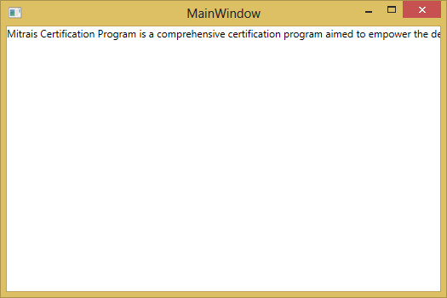
Figure 11 – Basic Controls – Clipped TextBox Control

- Stop debugging.
The clipping happens because the TextBlock control actually capable of dealing with long, multiline texts, but it will not do anything by default. In this case, the text is too long to be rendered inside the window, so WPF renders as much of the text as possible and then just stops.
Several ways are available to deal with this problem.
- Change the code block from the Grid to this:

<StackPanel>
<TextBlock Foreground="Red">
Mitrais Certification Program is a comprehensive certification program aimed to<LineBreak/>empower the developers
</TextBlock>
<TextBlock Foreground="Green" TextTrimming="CharacterEllipsis">
Mitrais Certification Program is a comprehensive certification program aimed to empower the developers
</TextBlock>
<TextBlock Foreground="Blue" TextWrapping="Wrap">
Mitrais Certification Program is a comprehensive certification program aimed to empower the developers
</TextBlock>
</StackPanel>

- Save and run the application
- You should see 3 TextBlock controls displaying the same text in different ways.

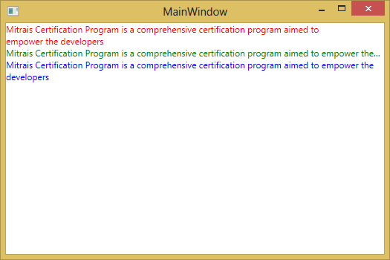
Figure 12 – Basic Controls – TextBox Controls With Long Text

In this example, a new kind of layout control: StackPanel is introduced. This will be discussed in the other section. The red TextBlock uses a LineBreak tag manually at a designated location. The green TextBlock uses TextTrimming property with CharacterEllipsis value to make the TextBlock show an ellipsis (…) when it cannot fit any more text into the control. The blue TextBlock uses TextWrapping property Wrap value to make the TextBlock wrap to the next line whenever it cannot fit anymore text into the previous line.
      - Label
The Label control, in its most simple form, will look very much like the TextBlock which we used in the previous subsection. Instead of a Text property, Label has a Content property. The reason for that is that the Label can host any kind of control directly inside of it, instead of just text. This content can be a string as well.
The main difference between Label and TextBlock is that the TextBlock only allows you to render a text string, while the Label also allows you to:
- Specify a border.
- Render other controls, e.g. an image.
- Use template content through the ContentTemplate property.
- Use access keys to give focus to related controls.
Example:

<Label>
Mitrais Certification Program
</Label>

Result:

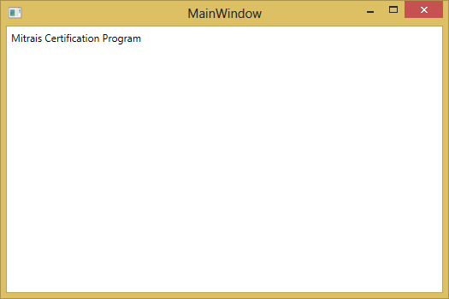
Figure 13 – Basic Controls – Label Control Example

      - TextBox
The TextBox control is such commonly used thing that you actually do not have to use any properties on it, to have a full-fledged editable text field.
Example:

<TextBox>
Mitrais Certification Program
</TextBox>

Result:

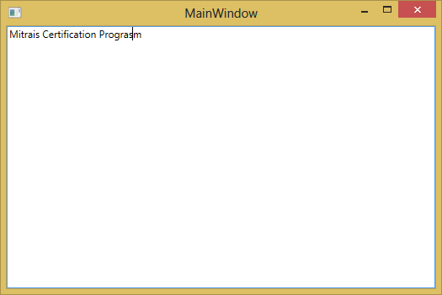
Figure 14 – Basic Controls – TextBox Control Example

      - CheckBox
The CheckBox control allows the end-user to toggle an option on or off, usually reflecting a Boolean value in the code-behind.
Example:

<StackPanel>
<Label FontWeight="Bold">Mitrais Certification Program Course Options</Label>
<CheckBox>XAML</CheckBox>
<CheckBox>WPF</CheckBox>
<CheckBox>WPF Style</CheckBox>
</StackPanel>

Result:

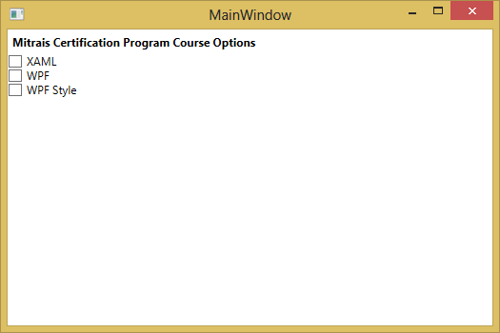
Figure 15 – Basic Controls – CheckBox Control Example

      - RadioButton
The RadioButton control allows you to give your user a list of possible options, with only one of them selected at the same time. You can achieve the same effect using the ComboBox control, but a set of radio buttons tend to give the user a better overview of the options they have, provided that the options available are not too many.
Example:

<StackPanel>
<Label FontWeight="Bold">Are you satisfied with the Mitrais Certification Program?</Label>
<RadioButton>Yes</RadioButton>
<RadioButton>No</RadioButton>
<RadioButton>Not Sure</RadioButton>
</StackPanel>

Result:
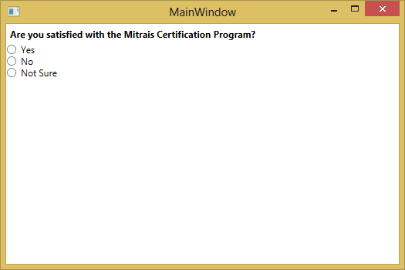
Figure 16 – Basic Controls – RadioButton Control Example

      - DataGrid
The DataGrid control provides a flexible way to display a collection of data in rows and columns. The DataGrid includes built-in column types and a template column for hosting custom content. The built-in row type includes a drop-down details section that you can use to display additional content below the cell values.
To bind the DataGrid to data set the ItemsSource property to an IEnumerable implementation. Each row in the data grid is bound to an object in the data source, and each column in the data grid is bound to a property of the data object. In order for the DataGrid user interface to update automatically when items are added to or removed from the source data, the DataGrid must be bound to a collection that implements INotifyCollectionChanged interface, such as ObservableCollection<T>. To automatically reflect property changes, the objects in the source collection must implement the INotifyPropertyChanged interface.
Example:

<StackPanel>
<DataGrid ItemsSource="{Binding Customers}"/>
</StackPanel>

Result:

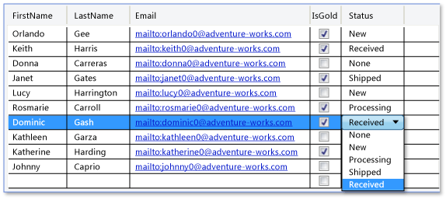
Figure 17 – Basic Controls – DataGrid Control Example

By default, the entire row is selected when a user clicks a cell in a DataGrid, and a user can select multiple rows. You can set the SelectionMode property to specify whether a user can select cells, full rows, or both. Set the SelectionUnit property to specify whether multiple rows or cells can be selected, or only single rows or cells. You can get information about the cells that are selected from the SelectedCells property. You can get the information about the cells for which selection has changed in the SelectedCellsChangedEventArgs of the SelectedCellsChanged event.
To group, sort, and filter data in the DataGrid, tou need to bind the DataGrid to an ICollectionView implementation that supports these operations. You can then perform the operations on the collection view.
By default, you can edit items directly in the DataGrid. To guarantee that edits can be committed and canceled correctly, the objects in the DataGrid must implement the IEditableObject interface. Alternatively, you can set the IsReadOnly property to true to disable edition in the DataGrid.
The DataGrid enables you to perform validation at both the cell and row level. With cell-level validation, you validate individual properties of a bound data object when a user updates a value. With row-level validation, you validate entire data objects when a user commits changes to a row.
    - Declaring, Using, and Debugging Basic WPF Controls Programmatically With Basic Event Handlers Using Control Lifecycle
Besides using XAML, we can fully use the code-behind to create and add controls to a window. In addition, creating basic event handlers can also be done programmatically, as shown in the example.
To create a basic button, follow these steps:
- Create a new project.
- In the MainWindow.xaml file, change the Grid code block to this:

<Window x:Class="CodeBehindControls.MainWindow"
xmlns="http://schemas.microsoft.com/winfx/2006/xaml/presentation"
xmlns:x="http://schemas.microsoft.com/winfx/2006/xaml"
Title="MainWindow" Height="350" Width="525" Loaded="Window_Loaded">
<StackPanel Name="myStackPanel">

</StackPanel>
</Window>

- In the code-behind of MainWindow, insert this code block:

private void Window_Loaded(object sender, RoutedEventArgs e)
{
Button myButton = new Button();
myButton.Content = "Click Me!";
myButton.Click += myButton_Click;
myStackPanel.Children.Add(myButton);
}

void myButton_Click(object sender, RoutedEventArgs e)
{
MessageBox.Show("Clicked");
}

The code myButton.Click += myButton_Click; is to subscribe the click event of the button control named myButton to myButton_Click method.
- Save and run the application.
- You should get this screen:

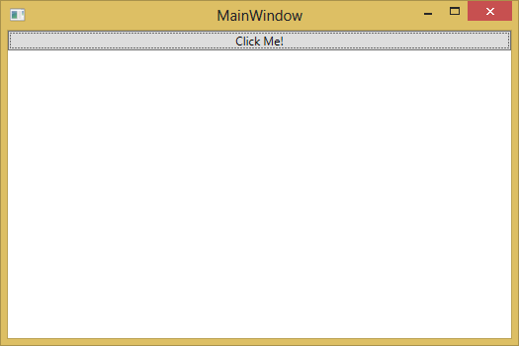
Figure 18 – Basic Controls – In-code Button Example

- Click the Click Me! Button.
- You should get this screen.

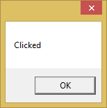
Figure 19 – Basic Controls – In-code Button Clicked Example

In this subsection, we also use an aspect of the control (window) lifecycle: the Loaded event. The complete lifecycle of a control (window) is as follows:
Any WPF framework-level element (those objects deriving from either FrameworkElement or FrameworkContentElement) has three common lifetime events (each implemented as events that can be handled):
- Initialized
Initialized is raised first, and roughly corresponds to the initialization of the object by the call to its constructor. Because the event happens in response to initialization, you are guaranteed that all properties of the object are set. As a consequence of the requirement that all properties are set, the sequence of Initialized being raised by nested elements are defined in markup appears to occur in order of deepest elements in the element tree first, then parent elements toward the root. This order is because the parent-child relationships and containment are properties, and therefore the parent cannot report initialization until the child elements that fill the property are also completely initialized.
When you are writing handlers in response to the Initialized event, you must consider that there is no guarantee that all other elements in the element tree (either logical tree or visual tree) around where the handler is attached have been created, particularly parent elements. Member variables may be null, or data sources might not yet be populated by the underlying binding.
- Loaded
Loaded is raised next. The Loaded event is raised before the final rendering, but after the layout system has calculated all necessary values for rendering. Loaded entails the completion of the logical parent tree of the element. Standard data bindings will have occurred prior to Loaded. Asynchronous data binding might have occurred, but by definition of its asynchronous nature cannot be guaranteed to have occurred.
The mechanism by which the Loaded event is raised is different than Initialized. The Initialized event is raised element by element, without a direct coordination by a completed element tree. By contrast, the Loaded event is raised as a coordinated effort throughout the entire element tree (specifically, the logical tree). When all elements in the tree are in a state where they are considered loaded, the Loaded event is first raised on the root element. The Loaded event is then raised successively on each child element.
- Unloaded
Unloaded is raised last and is initiated by either the presentation source or the visual parent being removed. When Unloaded is raised and handled, the element that is the event source parent (as determined by the Parent property) or any given element upwards in the logical or visual trees may have already been unset, meaning that data binding, resource references, and styles may not be set to their normal or last known run-time value.
    - Showing, Hiding, and Focusing on UI Elements
You can change a control’s visibility to show or hide it. Visibility.Visible will make the control visible. Visibility.Hidden will hide it, but still use up the space in the layout system, and Visibility.Collapsed will hide it and not use up space. The Visibility property applies for both Window and its elements.
To focus on a UI element, the common method is to use the Focus() method.
Specifically for Window objects, we can use Hide() and Show() method to hide and show them respectively.
Example of hiding a window upon loading (Loaded lifecycle event):
XAML file:

<Window x:Class="Focusing.MainWindow"
xmlns="http://schemas.microsoft.com/winfx/2006/xaml/presentation"
xmlns:x="http://schemas.microsoft.com/winfx/2006/xaml"
Title="MainWindow" Height="350" Width="525" Loaded="Window_Loaded">
<Grid>

</Grid>
</Window>

Code-behind:

private void Window_Loaded(object sender, RoutedEventArgs e)
{
this.Visibility = System.Windows.Visibility.Collapsed;
}

    - Using the Layout System and Layout Controls
      - Layout
The examples for the previous sections already used some layout system features and controls. At its simplest, layout is a recursive system that leads to an element being sized, positioned, and drawn. More specifically, layout describes the process of measuring and arranging the members of a Panel element’s Children collection. Layout is an intensive process. As the Children collection grows larger, the number of calculations that must be made becomes greater. Complexity can also be introduced based on the layout behavior defined by the Panel element that owns the collection. A relatively simple Panel, such as Canvas, can have significantly better performance than a more complex Panel, such as Grid.
Each time that a child UIElement changes its position, it has the potential to trigger a new pass by the layout system. Therefore, it is important to understand the events that can invoke the layout system, as unnecessary invocation can lead to poor application performance. The following describes the process that occurs when the layout system is invoked:
- A child UIElement begins the layout process by first having its core properties measured.
- Sizing properties defined on FrameworkElement are evaluated, such as Width, Height, and Margin.
- Panel-specific logic is applied, such as Dock direction or stacking Orientation.
- Content is arranged after all children have been measured.
- The Children collection is drawn on the screen.
- The process is invoked again if additional Children are added to the collection, a LayoutTransform is applied, or the UpdateLayout method is called.
The layout system completes two passes for each member of the Children collection: a measure pass and an arrange pass. Each child Panel provides its own MeasureOverride and ArrangeOverride methods to achieve its own specific layout behavior.
During the measure pass, each member of the Children collection is evaluated. The process begins with a call to the Measure method. This method is called within the implementation of the parent Panel element, and does not have to be called explicitly for layout to occur. The ultimate goal of the measure pass is for the child element to determine its DesiredSize.
The arrange pass begins with a call to the Arrange method. During the arrange pass, the parent Panel element generates a rectangle that represents the bounds of the child. The bounds value is then passed to the ArrangeCore method for offset properties such as margin, alignment, padding and final layout placement. Control is then returned to the parent Panel and layout process is complete.
      - Layout Panel Controls
WPF includes a group of elements that derive from Panel, allowing many complex layouts. For example, stacking elements can easily be achieved by using the StackPanel element, while more complex and free flowing layouts are possible by using a Canvas.
- Canvas
Defines an area within which you can explicitly position child elements by coordinates relative to the Canvas area.
The Canvas is the most basic layout panel in WPF. Its child elements are positioned by explicit coordinates. The coordinates can be specified relative to any side of the panel using the Canvas.Left, Canvas.Top, Canvas.Bottom, and Canvas.Right attached properties. Attached properties are the properties that are not owned by a class, but available to it via its parent (usually a container control).
- DockPanel
Defines an area within which you can arrange child elements either horizontally or vertically, relative to each other.
The dock panel is a layout panel that provides an easy docking of elements to the left, right, top, bottom or center of the panel. The dock side of an element is defined by the attached property DockPanel.Dock. To dock an element to the center of the panel, it must be the last child of the panel and the LastChildFill property must be set to true.
- Grid
The grid is a layout panel that arranges its child controls in a tabular structure of rows and columns. Its functionality is similar to the HTML table but more flexible. A cell can contain multiple controls; they can span over multiple cells and even overlap themselves.
The resize behaviour of the controls is defined by the HorizontalAlignment and VerticalAlignment properties who define the anchors. The distance between the anchor and the grid line is specified by the margin of the control.
- UniformGrid
The uniform grid control provides a similar layout to that given by the Grid layout control. Its child controls are organized into a tabular structure of rows and columns. Unlike the Grid control, you don't have fine-grained control of the layout. The column widths and row heights cannot be modified. These sizes are set automatically to ensure that all columns are the same width and all rows are of an equal height. In addition, where the Grid control permits you to specify a cell position for each child, the UniformGrid does not.
- StackPanel
The StackPanel in WPF is a simple and useful layout panel. It stacks its child elements below or beside each other, dependening on its orientation. This is very useful to create any kinds of lists. All WPF ItemsControls like ComboBox,ListBox or Menu use a StackPanel as their internal layout panel.
A good example for a horizontal stack panel is the "OK" and "Cancel" buttons of a dialog window. Because the size of the text can change if the user changes the font-size or switches the language we should avoid fixed sized buttons. The stack panel aligns the two buttons depending on their desired size. If they need more space they will get it automatically. Never mess again with too small or too large buttons.
- ViewBox
The ViewBox is a very useful control in WPF. It does not resize the content, but it transforms it. This means that also all text sizes and line widths were scaled. It is about the same behavior as if you set the Stretch property on an Image or Path to Uniform.
Although it can be used to fit any type of control, it is often used for 2D graphics, or to fit a scalable part of a user interface into a screen area.
- WrapPanel
The wrap panel is similar to the StackPanel, but it does not just stack all child elements to one row, it wraps them to new lines if no space is left. The Orientation can be set to Horizontal or Vertical.
The WrapPanel can be used to arrange tabs of a tab control, menu items in a toolbar or items in a Windows Explorer-like list. The WrapPanel is often used with items of the same size, but it is not a requirement.
      - Margins, Padding, and Alignment
There are numerous ways to position elements using WPF. However, achieving ideal layout goes beyond simply choosing the right Panel element. Fine control of positioning requires an understanding of the HorizontalAlignment, Margin, Padding and VerticalAlignment properties.
The following illustration shows a layout scenario that utilizes several positioning properties.

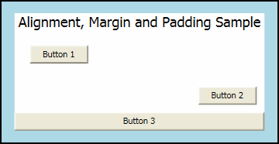
Figure 20 – Layout – Alignment, Margin and Padding Sample

At first glance, the Button elements in this illustration may appear to be placed randomly. However, their positions are actually precisely controlled by using a combination of margins, alignments, and padding.
The following diagram provides a close-up view of the various positioning properties that are used in the preceding sample.

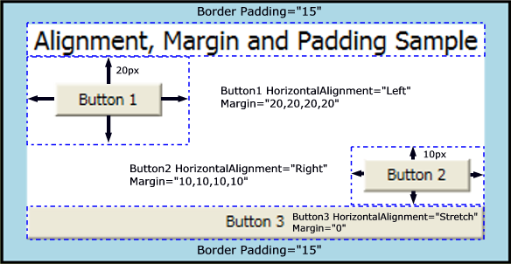
Figure 21 – Layout – Alignment, Margin and Padding Detailed Diagram

To try to create the above sample, please follow these steps:
- Create a new WPF project.
- In the XAML file, insert this code block:

<Window x:Class="MarginPaddingAlignment.MainWindow"
xmlns="http://schemas.microsoft.com/winfx/2006/xaml/presentation"
xmlns:x="http://schemas.microsoft.com/winfx/2006/xaml"
Title="MainWindow" Height="220" Width="400">
<Border Background="LightBlue" BorderBrush="Black" BorderThickness="2" Padding="15">
<StackPanel Background="White" HorizontalAlignment="Center" VerticalAlignment="Top">
<TextBlock Margin="5,0,5,0" FontSize="18" HorizontalAlignment="Center">Alignment, Margin and Padding Sample</TextBlock>
<Button HorizontalAlignment="Left" Margin="20">Button 1</Button>
<Button HorizontalAlignment="Right" Margin="10">Button 2</Button>
<Button HorizontalAlignment="Stretch" Margin="0">Button 3</Button>
</StackPanel>
</Border>
</Window>

- Save and run the application.
- You should see this screen:

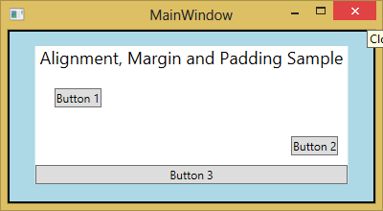
Figure 22 – Layout – Alignment, Margin and Padding Sample Application
    - Using WPF-Specific Controls
When exploring the controls in WPF, we will find controls that are only available in WPF. Some of the controls will be discussed in this section, so you will be able to quickly adapt and use them when necessary.
      - AccessText
The AccessText control in WPF converts a character preceded by an underscore to an Access Key. The Access Key is registered and therefore raises an event when pressed.
The AccessText element represents an AccessText control in XAML.
If there are multiple underscore characters, only the first one is converted into an AccessKey; the other underscores appear as normal text. If the underscore that you want converted to the access key is not the first underscore, use two consecutive underscores for any underscores that precede the one that you want to convert.
Example:

<Button Name="Button1" Width="120" Height="50" Margin="33,70,59,124"
FontSize="16" Click="Button1_Click">
<AccessText>_Click Me</AccessText>
</Button>

Result:

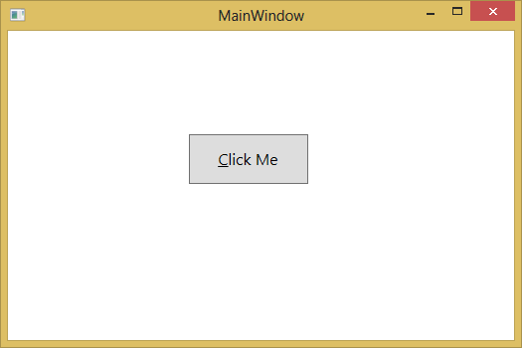
Figure 23 – WPF-Specific Controls – AccessText Sample Application

      - DocumentViewer
The DocumentViewer control is designed to display fixed document content. The DocumentViewer control provides an intuitive user interface that provides built-in support for common operations including print output, copy to clipboard, zoom, and text search features. The control provides access to pages of content through a familiar scrolling mechanism. Like all WPF controls, DocumentViewer supports complete or partial restyling, which enables the control to be visually integrated into virtually any application or environment.
DocumentViewer is designed to display content in a read-only manner; editing or modification of content is not available and is not supported.
To try using this control, please follow these steps:
- Create a new WPF project.
- Add a reference to Reach Framework.
- Right-click References under the project name in the Solution Explorer.
- Select Add Reference and in the Add Reference dialog box, choose ReachFramework and click the OK button.

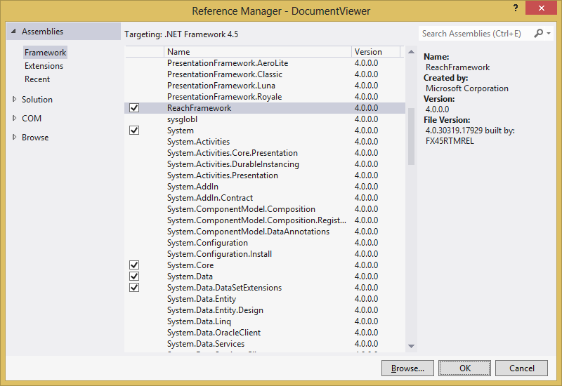
Figure 24 – WPF-Specific Controls – Add Project Reference Screen

- The DocumentViewer controls natively supports XPS document file format. Make sure that you have an XPS document ready.
- In the MainWindow.xaml file, insert this block of code between the Grid tags:

<DocumentViewer x:Name="documentViewer1">
<FixedDocument>

</FixedDocument>
</DocumentViewer>

- In the code-behind file, make sure that the code looks like this:

using System;
using System.Collections.Generic;
using System.Linq;
using System.Text;
using System.Threading.Tasks;
using System.Windows;
using System.Windows.Controls;
using System.Windows.Data;
using System.Windows.Documents;
using System.Windows.Input;
using System.Windows.Media;
using System.Windows.Media.Imaging;
using System.Windows.Navigation;
using System.Windows.Shapes;
using System.Windows.Xps.Packaging;

namespace DocumentViewer
{
/// <summary>
/// Interaction logic for MainWindow.xaml
/// </summary>
public partial class MainWindow : Window
{
public MainWindow()
{
InitializeComponent();

XpsDocument document1 = new XpsDocument(@"D:\Text.xps", System.IO.FileAccess.Read);
documentViewer1.Document = document1.GetFixedDocumentSequence();
}
}
}

Where the "D:\Text.xps" string should be replaced with the path of your own test XPS document file.

- Save and run the application.
- You should see this kind of screen:

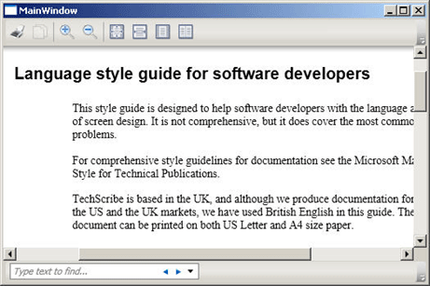
Figure 25 – WPF-Specific Controls – DocumentViewer Application Sample

As you can see, the DocumentViewer control offers a full-featured document viewer.
      - FlowDocumentReader
FlowDocumentReader includes features that enable the user to dynamically choose between various viewing modes, including a single-page (page-at-a-time) viewing mode, a two-page-at-a-time (book reading format) viewing mode, and a continuous scrolling (bottomless) viewing mode. If you do not need the ability to dynamically switch between different viewing modes, FlowDocumentPageViewer and FlowDocumentScrollViewer provide lighter-weight flow content viewers that are fixed in a particular viewing mode.
To try the features of the FlowDocumentReader control, please follow these steps:
- Create a new WPF project.
- In the MainWindow.xaml file, insert this code block:

<FlowDocumentReader>
<FlowDocument>
<Paragraph>
<Bold>Some bold text in the paragraph.</Bold>
Some text that is not bold.
</Paragraph>

<List>
<ListItem>
<Paragraph>ListItem 1</Paragraph>
</ListItem>
<ListItem>
<Paragraph>ListItem 2</Paragraph>
</ListItem>
<ListItem>
<Paragraph>ListItem 3</Paragraph>
</ListItem>
</List>

</FlowDocument>
</FlowDocumentReader>

- Save and run the application.
- You should see this screen:

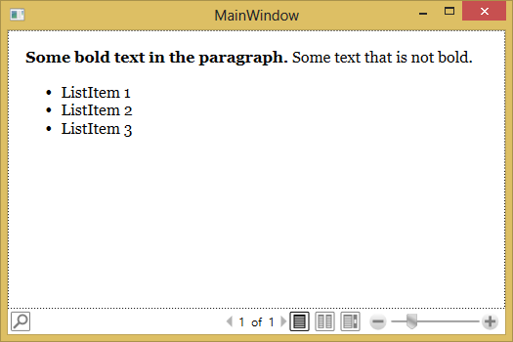
Figure 26 – WPF-Specific Controls – FlowDocumentViewer Application Sample

    - Styling WPF Controls
      - Styling Fundamentals
Imagine you that want to create an application with a unique design. All your buttons should have an orange background and an italic font. If you do this the conventional way, you have to set the Background and the FontStyle property on every single button.

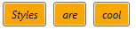
Figure 27 – WPF Styling – Button Design Sample

The above buttons use this code block in the XAML file:

<StackPanel Orientation="Horizontal" VerticalAlignment="Top">
<Button Background="Orange" FontStyle="Italic"
Padding="8,4" Margin="4">Styles</Button>
<Button Background="Orange" FontStyle="Italic"
Padding="8,4" Margin="4">are</Button>
<Button Background="Orange" FontStyle="Italic"
Padding="8,4" Margin="4">cool</Button>
</StackPanel>

This code is neither maintainable nor short and clear. The solution for this problem is styles.
The concept of styles let you remove all properties values from the individual user interface elements and combine them into a style. A style consists of a list of setters. If you apply this style to an element it sets all properties with the specified values. The idea is quite similar to Cascading Styles Sheets (CSS) that we know from web development.
To make the style accessible to your controls you need to add it to the resources. Any control in WPF has a list of resources that is inherited to all controls beneath the visual tree. That is the reason why we need to specify a x:Key="myStyle" property that defines a unique resource identifier.
To apply the style to a control we set the Style property to our style. To get it from the resources we use the {StaticResource [resourceKey]} markup extension.
Using the style concept, the above block of code can be replaced with this block, with the same result:

<Window.Resources>
<Style x:Key="myStyle" TargetType="Button">
<Setter Property="Background" Value="Orange" />
<Setter Property="FontStyle" Value="Italic" />
<Setter Property="Padding" Value="8,4" />
<Setter Property="Margin" Value="4" />
</Style>
</Window.Resources>

<StackPanel Orientation="Horizontal" VerticalAlignment="Top">
<Button Style="{StaticResource myStyle}">Styles</Button>
<Button Style="{StaticResource myStyle}">are</Button>
<Button Style="{StaticResource myStyle}">cool</Button>
</StackPanel>

Using the above approach, we can get:
- A maintainable code base.
- Removed redundancy.
- Change the appearance of a set of controls from a single point.
- Possibility to swap the styles at runtime.
A style in WPF can base on another style. This allows you to specify a base style that sets common properties and derive from it for specialized controls.

<Style x:Key="baseStyle">
<Setter Property="FontSize" Value="12" />
<Setter Property="Background" Value="Orange" />
</Style>

<Style x:Key="boldStyle" BasedOn="{StaticResource baseStyle}">
<Setter Property="FontWeight" Value="Bold" />
</Style>

      - Resources
In the above examples, we introduced the Window.Resources tag. It is an identifier to specify window-level resources. A resource is an object that can be reused in different places in your application. Examples of resources include brushes and styles. This overview describes how to use resources in XAML. You can also create and access resources by using code, or interchangeably between code and Extensible Application Markup Language (XAML).
The following example defines a SolidColorBrush as a resource on the root element of a page. The example then references the resource and uses it to set properties of several child elements, including an Ellipse, a TextBlock, and a Button.

<Page Name="root"
xmlns="http://schemas.microsoft.com/winfx/2006/xaml/presentation"
xmlns:x="http://schemas.microsoft.com/winfx/2006/xaml"
>
<Page.Resources>
<SolidColorBrush x:Key="MyBrush" Color="Gold"/>
<Style TargetType="Border" x:Key="PageBackground">
<Setter Property="Background" Value="Blue"/>
</Style>
<Style TargetType="TextBlock" x:Key="TitleText">
<Setter Property="Background" Value="Blue"/>
<Setter Property="DockPanel.Dock" Value="Top"/>
<Setter Property="FontSize" Value="18"/>
<Setter Property="Foreground" Value="#4E87D4"/>
<Setter Property="FontFamily" Value="Trebuchet MS"/>
<Setter Property="Margin" Value="0,40,10,10"/>
</Style>
<Style TargetType="TextBlock" x:Key="Label">
<Setter Property="DockPanel.Dock" Value="Right"/>
<Setter Property="FontSize" Value="8"/>
<Setter Property="Foreground" Value="{StaticResource MyBrush}"/>
<Setter Property="FontFamily" Value="Arial"/>
<Setter Property="FontWeight" Value="Bold"/>
<Setter Property="Margin" Value="0,3,10,0"/>
</Style>
</Page.Resources>
<StackPanel>
<Border Style="{StaticResource PageBackground}">
<DockPanel>
<TextBlock Style="{StaticResource TitleText}">Title</TextBlock>
<TextBlock Style="{StaticResource Label}">Label</TextBlock>
<TextBlock DockPanel.Dock="Top" HorizontalAlignment="Left" FontSize="36" Foreground="{StaticResource MyBrush}" Text="Text" Margin="20" />
<Button DockPanel.Dock="Top" HorizontalAlignment="Left" Height="30" Background="{StaticResource MyBrush}" Margin="40">Button</Button>
<Ellipse DockPanel.Dock="Top" HorizontalAlignment="Left" Width="100" Height="100" Fill="{StaticResource MyBrush}" Margin="40" />
</DockPanel>
</Border>
</StackPanel>
</Page>

Every framework-level element (FrameworkElement or FrameworkContentElement) has a Resource property, which is the property that contains the resources (as a ResourceDictionary) that a resource defines. You can define resources on any element. However, resources are most often defined on the root element, which is Page in the example.
Each resource in a resource dictionary must have a unique key. When you define resources in markup, you assign the unique key through the x:Key Directive. Typically, the key is a string; however, you can also set it to other object types by using the appropriate markup extensions. Non-string keys for resources are used by certain feature areas in WPF, notably for styles, component resources, and data styling.
After you define a resource, you can reference the resource to be used for a property value by using a resource markup extension syntax that specifies the key name, for example:

<Button Background="{StaticResource MyBrush}"/>
<Ellipse Fill="{StaticResource MyBrush}"/>

In the preceding example, when the XAML loader processes the value {StaticResource MyBrush} for the Background property on Button, the resource lookup logic first checks the resource dictionary for the Button element. If Button does not have a definition of the resource key MyBrush (it does not; its resource collection is empty), the lookup next checks the parent element of Button, which is Page. Thus, when you define a resource on the Page root element, all the elements in the logical tree of the Page can access it, and you can reuse the same resource for setting the value of any property that accepts the Type that the resource represents. In the previous example, the same MyBrush resource sets two different properties: the Background of a Button, and the Fill of a Rectangle.
      - Static and Dynamic Resources
A resource can be referenced as either a static resource or a dynamic resource. This is done by using either the StaticResource Markup Extension or the DynamicResource Markup Extension. A markup extension is a feature of XAML whereby you can specify an object reference by having the markup extension process the attribute string and return the object to a XAML loader.
When you use a markup extension, you typically provide one or more parameters in string form that are processed by that particular markup extension, rather than being evaluated in the context of the property being set. The StaticResource Markup Extension processes a key by looking up the value for that key in all available resource dictionaries. This happens during loading, which is the point in time when the loading process needs to assign the property value that takes the static resource reference. The DynamicResource instead processes a key by creating an expression, and that expression remains unevaluated until the application is actually run, at which time the expression is evaluated and provides a value.
When you reference a resource, the following considerations can influence whether you use a static resource reference or a dynamic resource reference:
- The overall design of how you create the resources for your application (per page, in the application, in loose XAML, in a resource only assembly).
- The application functionality: is updating resources in real time part of your application requirements?
- The respective lookup behavior of that resource reference type.
- The particular property or resource type, and the native behavior of those types.
      - Merged Resource Dictionaries
Windows Presentation Foundation (WPF) resources support a merged resource dictionary feature. This feature provides a way to define the resources portion of a WPF application outside of the compiled XAML application. Resources can then be shared across applications and are also more conveniently isolated for localization.
In markup, you use the following syntax to introduce a merged resource dictionary into a page:

<Page.Resources>
<ResourceDictionary>
<ResourceDictionary.MergedDictionaries>
<ResourceDictionary Source="myresourcedictionary.xaml"/>
<ResourceDictionary Source="myresourcedictionary2.xaml"/>
</ResourceDictionary.MergedDictionaries>
</ResourceDictionary>
</Page.Resources>

Note that the ResourceDictionary element does not have an x:Key Directive, which is generally required for all items in a resource collection. But another ResourceDictionary reference within the MergedDictionaries collection is a special case, reserved for this merged resource dictionary scenario. The ResourceDictionary that introduces a merged resource dictionary cannot have an x:Key Directive. Typically, each ResourceDictionary within the MergedDictionaries collection specifies a Source attribute. The value of Source should be a uniform resource identifier (URI) that resolves to the location of the resources file to be merged. The destination of that URI must be another XAML file, with ResourceDictionary as its root element.
      - Styles and Resources
You can use a style on any element that derives from FrameworkElement or FrameworkContentElement. The most common way to declare a style is as a resource in the Resources section in a XAML file, as shown in the previous examples. Because styles are resources, they obey the same scoping rules that apply to all resources; where you declare a style affects where the style can be applied. For example, if you declare the style in the root element of your application definition XAML file, the style can be used anywhere in your application. If you create a navigation application and declare the style in one of the application's XAML files, the style can be used only in that XAML file.
To assign a named style to an element programmatically, get the style from the resources collection and assign it to the element's Style property. Note that the items in a resources collection are of type Object. Therefore, you must cast the retrieved style to a Style before assigning it to the Style property. For example, to set the definedTitleText style on a TextBlock named textblock1, do the following:

textblock1.Style = (Style)(this.Resources["TitleText"]);

Note that once a style has been applied, it is sealed and cannot be changed. If you want to dynamically change a style that has already been applied, you must create a new style to replace the existing one.
You can create an object that chooses a style to apply based on custom logic.
      - Control Templates
In WPF, the ControlTemplate of a control defines the appearance of the control. You can change the structure and appearance of a control by defining a new ControlTemplate for the control. In many cases, this gives you enough flexibility so that you do not have to write your own custom controls.
A ControlTemplate specifies the visual structure and visual behavior of a control. You can customize the appearance of a control by giving it a new ControlTemplate. When you create a ControlTemplate, you replace the appearance of an existing control without changing its functionality. For example, you can make the buttons in your application round instead of the default square shape, but the button will still raise the Click event.
Controls have many properties, such as Background, Foreground, and FontFamily, that you can set to specify different aspects of the control's appearance, but the changes that you can make by setting these properties are limited. For example, you can set the Foreground property to blue and FontStyle to italic on a Checkbox.
The control template is often included in a style that contains other property settings. The following code sample shows a simple control template for a button with an ellipse shape.

<Style x:Key="DialogButtonStyle" TargetType="Button">
<Setter Property="Template">
<Setter.Value>
<ControlTemplate TargetType="{x:Type Button}">
<Grid>
<Ellipse Fill="{TemplateBinding Background}"
Stroke="{TemplateBinding BorderBrush}"/>
<ContentPresenter HorizontalAlignment="Center"
VerticalAlignment="Center"/>
</Grid>
</ControlTemplate>
</Setter.Value>
</Setter>
</Style>

<Button Style="{StaticResource DialogButtonStyle}" />

When you create a custom control template and you want to define a placeholder that renders the content, you can use the ContentPresenter. By default it adds the content of the Content property to the visual tree of the template. To display the content of another property you can set the ContentSource to the name of the property you like.
      - Data Template
Data Templates are a similar concept as Control Templates. They give you a very flexible and powerful solution to replace the visual appearance of a data item in a control like ListBox, ComboBox or ListView.
If you do not specify a data template, WPF takes the default template that is just a TextBlock. If you bind complex objects to the control, it just calls ToString() on it. Within a DataTemplate, the DataContext is set the data object. So you can easily bind against the data context to display various members of your data object.
    - Creating and Using User-Defined Controls
WPF has two concepts of user-defined controls: UserControls and CustomControls.
- UserControl
- Composes multiple existing controls into a reusable "group".
- Consists of a XAML and a code behind file.
- Cannot be styled/template.
- Derives from UserControl.
- CustomControl (extend existing control)
- Extends an existing control with additional features
- Consists of a code file and a default style in Themes/Generic.xaml
- Can be styled/templated
- The best approach to build a control library
      - UserControl
In this subsection, we will try to create and then use a UserControl that is also called a Composite Control.
The composite control will be a file browser control.
To start creating the user control, please follow these steps:
- Create a new WPF project.
- Right-click on the project name.
- Select Add > User Control.
- Name the user control XAMLFileBrowser.xaml.

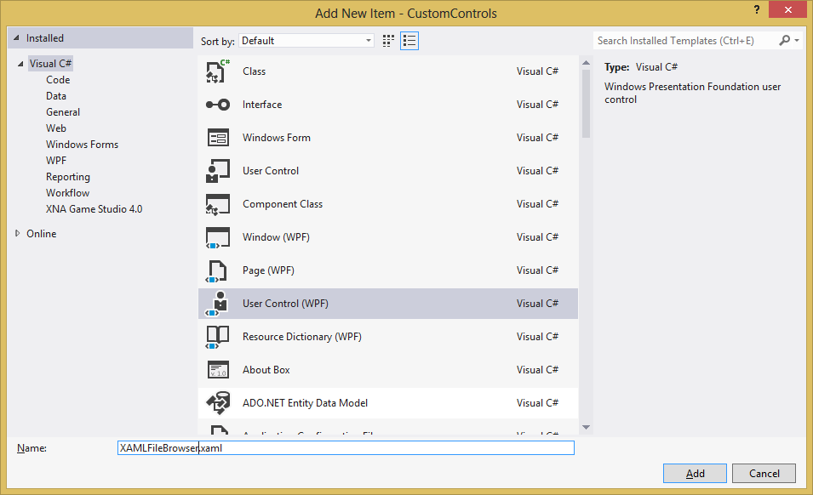
Figure 28 – User-Defined Controls – Add User Control Screen

- Click OK.
- In the XAMLFileBrowser.xaml file, insert this code block:

<UserControl xmlns="http://schemas.microsoft.com/winfx/2006/xaml/presentation"
xmlns:x="http://schemas.microsoft.com/winfx/2006/xaml"
xmlns:mc="http://schemas.openxmlformats.org/markup-compatibility/2006"
xmlns:d="http://schemas.microsoft.com/expression/blend/2008"
mc:Ignorable="d"
x:Class="CustomControls.XamlFileBrowser"
x:Name="XAMLFileBrowserControl"
d:DesignHeight="39" d:DesignWidth="397">
<Grid x:Name="LayoutRoot">
<Grid.ColumnDefinitions>
<ColumnDefinition Width="0.352*"/>
<ColumnDefinition Width="0.648*"/>
</Grid.ColumnDefinitions>
<TextBox x:Name="FBCTextBox" Margin="4,10.313,137,4.001" Text="TextBox" TextWrapping="Wrap" Grid.ColumnSpan="2" TextChanged="FBCTextBox_TextChanged" />
<Button x:Name="FBCButton" HorizontalAlignment="Right" Margin="0,8,13,4" Width="111" Content="Browse"
Grid.Column="1" Click="FBCButton_Click" />
</Grid>
</UserControl>

The above code will create a composite control that has a TextBox and a Button in it.

- Go to the code behind of XAMLFileBrowser.xaml.
- Make sure that the code looks like this:

using System;
using System.Collections.Generic;
using System.Linq;
using System.Text;
using System.Threading.Tasks;
using System.Windows;
using System.Windows.Controls;
using System.Windows.Data;
using System.Windows.Documents;
using System.Windows.Input;
using System.Windows.Media;
using System.Windows.Media.Imaging;
using System.Windows.Navigation;
using System.Windows.Shapes;

namespace CustomControls
{
/// <summary>
/// Interaction logic for XAMLFileBrowser.xaml
/// </summary>
public partial class XAMLFileBrowser : UserControl
{
public string FileName
{
get { return FBCTextBox.Text; }
set { FBCTextBox.Text = value; }
}

public event EventHandler<EventArgs> FileNameChanged;

public XAMLFileBrowser()
{
InitializeComponent();
}

private void FBCButton_Click(object sender, RoutedEventArgs e)
{
Microsoft.Win32.OpenFileDialog openFileDlg = new Microsoft.Win32.OpenFileDialog();
if (openFileDlg.ShowDialog() == true)
this.FileName = openFileDlg.FileName;
}

private void FBCTextBox_TextChanged(object sender, TextChangedEventArgs e)
{
e.Handled = true;
if (FileNameChanged != null)
FileNameChanged(this, EventArgs.Empty);
}
}
}

The above code will set a handler for the TextBox’s text changed event, and another one for the Button’s click event.

- Go to the MainWindow.xaml file.
- Insert this code block:

<Window x:Class="CustomControls.MainWindow"
xmlns="http://schemas.microsoft.com/winfx/2006/xaml/presentation"
xmlns:x="http://schemas.microsoft.com/winfx/2006/xaml"
xmlns:local="clr-namespace:CustomControls"
Title="MainWindow" Height="100" Width="525">
<Grid>
<local:XAMLFileBrowser />
</Grid>
</Window>

- Save and run the application.
- You should see this kind of screen:

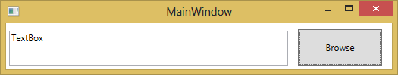
Figure 29 – User-Defined Controls – User Control Example

- You can play with the Browse button and the text box.
      - CustomControl
Another type of user-defined control is the CustomControl, where we extend an existing control to suit our needs.
The custom control will be a button that can be decorated with an image.
To start creating the custom control, please follow these steps:
- From the previous user control solution example, add a new Custom Control library project called ImageButton.

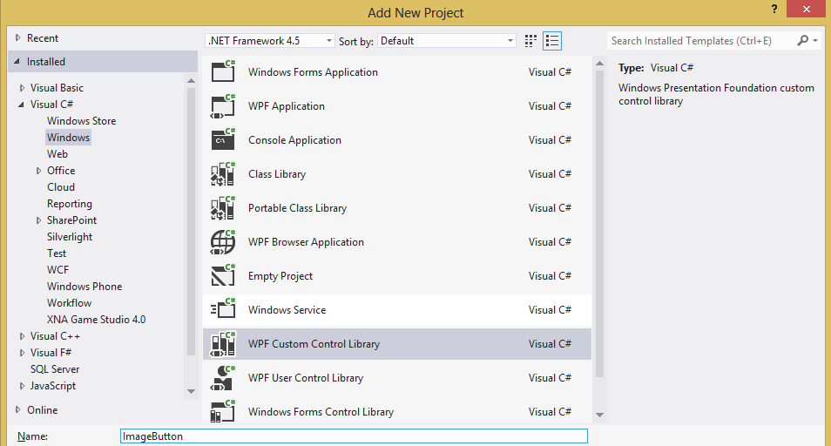
Figure 30 – User-Defined Controls – Custom Control Library Project Screen

- From the Solution Explorer pane, rename the CustomControl1.cs class file to ImageButtonControl.cs.

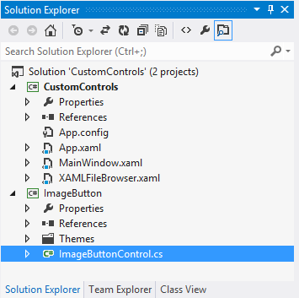
Figure 31 – User-Defined Controls – Custom Control Library Project Structure

- In ImageButtonControl.cs file, use the following code to replace the class definition:

public class ImageButtonControl : Button
{
public static readonly DependencyProperty SourceProperty =
DependencyProperty.Register("Source", typeof(ImageSource), typeof(ImageButtonControl));

public ImageSource Source
{
get { return base.GetValue(SourceProperty) as ImageSource; }
set { base.SetValue(SourceProperty, value); }
}

static ImageButtonControl()
{
DefaultStyleKeyProperty.OverrideMetadata(typeof(ImageButtonControl), new FrameworkPropertyMetadata(typeof(ImageButtonControl)));
}
}

The Source will become a new dependency property that will be specific to ImageButtonControl class.

- We will now create a default style for the custom control. The style must be located in a folder called “Themes” that must be located in the root of the control library project. In these folders, we can provide different templates for each Windows Theme. The name of these ResourceDictionaries must match the name of the windows theme. If we do not provide any theme-specific styles, we need to provide the fallback style located in the Generic.xaml file.
As we set the default value of the DefaultStyleKey property to the Type object of our control, we must give our default style the same key to be found. This is done by leaving the x:Key attribute out. In this case, WPF uses the type object from the TargetType property as key.
In Themes\Generix.xaml file, insert this code:

<ResourceDictionary
xmlns="http://schemas.microsoft.com/winfx/2006/xaml/presentation"
xmlns:x="http://schemas.microsoft.com/winfx/2006/xaml"
xmlns:local="clr-namespace:ImageButton">
<Style TargetType="{x:Type local:ImageButtonControl}">
<Setter Property="Template">
<Setter.Value>
<ControlTemplate TargetType="{x:Type local:ImageButtonControl}">
<Border Background="{TemplateBinding Background}"
BorderBrush="{TemplateBinding BorderBrush}"
BorderThickness="{TemplateBinding BorderThickness}">
<Grid>
<Grid.ColumnDefinitions>
<ColumnDefinition Width="100"/>
<ColumnDefinition Width="*"/>
</Grid.ColumnDefinitions>
<Image Source="{TemplateBinding Source}" Grid.Column="0" Height="90" Width="90" Stretch="Uniform"/>
<ContentPresenter Grid.Column="1" VerticalAlignment="Center"></ContentPresenter>
</Grid>
</Border>
</ControlTemplate>
</Setter.Value>
</Setter>
</Style>
</ResourceDictionary>

- Back to the CustomControls project, add a reference to the new ImageButton project, by right-clicking on the References node from Solution Explorer pane, and selecting Add Reference.
- Select the Projects pane, and check the ImageButton project.
- Click OK.

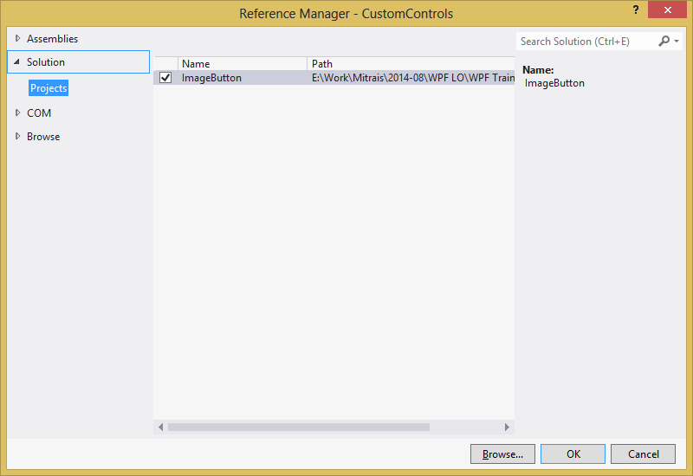
Figure 32 – User-Defined Controls – Add Reference Screen

- Make sure that the file LOGO.bmp exists in the path D:\, or any path that you want.
- In MainWindow.xaml file, modify the markup to this code block:

<Window x:Class="CustomControls.MainWindow"
xmlns="http://schemas.microsoft.com/winfx/2006/xaml/presentation"
xmlns:x="http://schemas.microsoft.com/winfx/2006/xaml"
xmlns:local="clr-namespace:CustomControls"
xmlns:imageButton="clr-namespace:ImageButton;assembly=ImageButton"
Title="MainWindow" Height="250" Width="525">
<Grid>
<Grid.RowDefinitions>
<RowDefinition Height="100"/>
<RowDefinition Height="*"/>
</Grid.RowDefinitions>
<local:XAMLFileBrowser Grid.Row="0" />
<imageButton:ImageButtonControl Grid.Row="1" Source="D:\LOGO.bmp">
Test Image Button
</imageButton:ImageButtonControl>
</Grid>
</Window>

- Save and run the application.
- You should see a screen like the one in the previous section, plus a button with an image on the left side and text content on its right side.
- You can use the same behavior as the Button control such as adding the Click event.

    - Using Data Binding
      - Dependency Properties
WPF provides a simple and powerful way to auto-update data between the business model and the user interface. This mechanism is called DataBinding. Every time the data of your business model changes, it automatically reflects the updates to the user interface and vice versa. This is the preferred method in WPF to bring data to the user interface.
Databinding can be unidirectional (source -> target or target <- source), or bidirectional (source <-> target).
The source of a databinding can be a normal .NET property or a DependencyProperty. The target property of the binding must be a DependencyProperty.
The purpose of dependency properties is to provide a way to compute the value of a property based on the value of other inputs. These other inputs might include system properties such as themes and user preference, just-in-time property determination mechanisms such as data binding and animations/storyboards, multiple-use templates such as resources and styles, or values known through parent-child relationships with other elements in the element tree. In addition, a dependency property can be implemented to provide self-contained validation, default values, callbacks that monitor changes to other properties, and a system that can coerce property values based on potentially runtime information. Derived classes can also change some specific characteristics of an existing property by overriding dependency property metadata, rather than overriding the actual implementation of existing properties or creating new properties.
To make the databinding properly work, both sides of a binding must provide a change notification that tells the binding when to update the target value. On normal .NET properties this is done by raising the PropertyChanged event of the INotifyPropertyChanged interface. On DependencyProperties it is done by the PropertyChanged callback of the property metadata.
Databinding is typically done in XAML by using the {Binding} markup extension. The following example shows a simple binding between the text of a TextBox and a Label that reflects the typed value:

<StackPanel>
<TextBox x:Name="txtInput" />
<Label Content="{Binding Text, ElementName=txtInput,
UpdateSourceTrigger=PropertyChanged}" />
</StackPanel>

      - DataContext
Every WPF control derived from FrameworkElement has a DataContext property. This property is meant to be set to the data object it visualizes. If you do not explicity define a source of a binding, it takes the code behind as data context by default.
The DataContext property inherits its value to child elements. So you can set the DataContext on a superior layout container and its value is inherited to all child elements. This is very useful if you want to build a form that is bound to multiple properties of the same data object.

<StackPanel DataContext="{StaticResource myCustomer}">
<TextBox Text="{Binding FirstName}"/>
<TextBox Text="{Binding LastName}"/>
<TextBox Text="{Binding Street}"/>
<TextBox Text="{Binding City}"/>
</StackPanel>

      - ValueConverters
If you want to bind two properties of different types together, you need to use a ValueConverter. A ValueConverter converts the value from a source type to a target type and back. WPF already includes some value converters but in most cases you will need to write your own by implementing the IValueConverter interface.
A typical example is to bind a boolean member to the Visibility property. Since the visibility is an enum value that can be Visible, Collapsed or Hidden, you need a value converter.

<StackPanel>
<StackPanel.Resources>
<BooleanToVisibilityConverter x:Key="boolToVis" />
</StackPanel.Resources>

<CheckBox x:Name="chkShowDetails" Content="Show Details" />
<StackPanel x:Name="detailsPanel"
Visibility="{Binding IsChecked, ElementName=chkShowDetails,
Converter={StaticResource boolToVis}}">
</StackPanel>
</StackPanel>

The following example shows a simple converter that converts a boolen to a visibility property. Note that such a converter is already part of the .NET framework.

public class BooleanToVisibilityConverter : IValueConverter
{
public object Convert(object value, Type targetType, object parameter,
CultureInfo culture)
{
if (value is Boolean)
{
return ((bool)value) ? Visibility.Visible : Visibility.Collapsed;
}

return value;
}

public object ConvertBack(object value, Type targetType, object parameter, CultureInfo culture)
{
throw new NotImplementedException();
}
}

      - Data Binding
We will simulate data binding using the code-behind as the data context. To start this lesson, please follow these steps:
- Create a new project.
- In the MainWindow.xaml, insert this code block:

<Window x:Class="DataBinding.MainWindow"
xmlns="http://schemas.microsoft.com/winfx/2006/xaml/presentation"
xmlns:x="http://schemas.microsoft.com/winfx/2006/xaml"
Title="MainWindow" Height="350" Width="525" Loaded="Window_Loaded">
<Grid>
<TextBlock Text="{Binding FormattedDate, StringFormat=dd-MMMM-yyyy}" />
</Grid>
</Window>

The above code will data bind the content of FormattedDate property of the data context to the Text property of the TextBlock control.

- In the code behind of MainWindow class, make sure that the code looks like this:

using System;
using System.Collections.Generic;
using System.Linq;
using System.Text;
using System.Threading.Tasks;
using System.Windows;
using System.Windows.Controls;
using System.Windows.Data;
using System.Windows.Documents;
using System.Windows.Input;
using System.Windows.Media;
using System.Windows.Media.Imaging;
using System.Windows.Navigation;
using System.Windows.Shapes;

namespace DataBinding
{
/// <summary>
/// Interaction logic for MainWindow.xaml
/// </summary>
public partial class MainWindow : Window
{
private DateTime _formattedDate = new DateTime(2014, 8, 20);
public DateTime FormattedDate
{
get { return _formattedDate; }
set { _formattedDate = value; }
}

public MainWindow()
{
InitializeComponent();
}

private void Window_Loaded(object sender, RoutedEventArgs e)
{
this.DataContext = this;
}
}
}

The code will set the data context for MainWindow class to itself and create the FormattedDate property.

- Save and run the application.
- You should see this kind of screen:

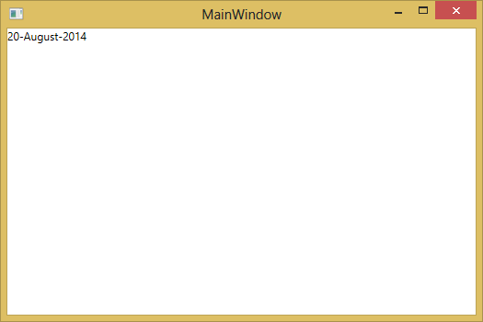
Figure 33 – Data Binding – Data Binding Example

- Stop debugging.
- Change the code block between the Grid tags to look like this:

<Grid.Resources>
<Style x:Key="styleFormat" TargetType="TextBlock">
<Setter Property="TextDecorations" Value="Underline"></Setter>
</Style>
</Grid.Resources>
<TextBlock Text="{Binding FormattedDate, StringFormat=dd-MMMM-yyyy }" Style="{StaticResource styleFormat}" />

- Save and run the application again.
- You should see this kind of screen:

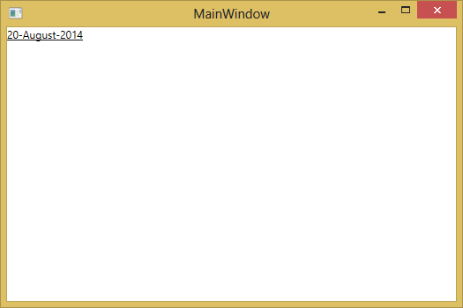
Figure 34 – Data Binding – Formatting Displayed Data Using Resources Example

You may want your application to enable users to change the data and propagate it back to the source object. Or you may not want to enable users to update the source data. You can control this by setting the Mode property of your Binding object. The following figure illustrates the different types of data flow:

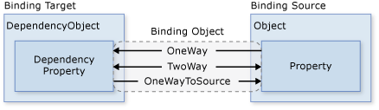
Figure 35 – Data Binding – Binding Directions

- OneWay binding causes changes to the source property to automatically update the target property, but changes to the target property are not propagated back to the source property. This type of binding is appropriate if the control being bound is implicitly read-only. For instance, you may bind to a source such as a stock ticker or perhaps your target property has no control interface provided for making changes, such as a data-bound background color of a table. If there is no need to monitor the changes of the target property, using the OneWay binding mode avoids the overhead of the TwoWay binding mode.
- TwoWay binding causes changes to either the source property or the target property to automatically update the other. This type of binding is appropriate for editable forms or other fully-interactive UI scenarios. Most properties default to OneWay binding, but some dependency properties (typically properties of user-editable controls such as the Text property of TextBox and the IsChecked property of CheckBox) default to TwoWay binding. A programmatic way to determine whether a dependency property binds one-way or two-way by default is to get the property metadata of the property using GetMetaData and then check the Boolean value of the BindsTwoWayByDefault property.
- OneWayToSource is the reverse of OneWay binding; it updates the source property when the target property changes. One example scenario is if you only need to re-evaluate the source value from the UI.
- Not illustrated in the figure is OneTime binding, which causes the source property to initialize the target property, but subsequent changes do not propagate. This means that if the data context undergoes a change or the object in the data context changes, then the change is not reflected in the target property. This type of binding is appropriate if you are using data where either a snapshot of the current state is appropriate to use or the data is truly static. This type of binding is also useful if you want to initialize your target property with some value from a source property and the data context is not known in advance. This is essentially a simpler form of OneWay binding that provides better performance in cases where the source value does not change.
    - Using Input Validation and Dialogs
A common requirement for any user interface application that accepts user input is to validate the entered information to ensure that it has the expected format and type for the back-end to be able to accept and persist it. This section is about how data validation works in WPF and the different validation options there are available including implementing custom ValidationRules and using the IDataErrorInfo interface and the INotifyErrorDataError interface that was introduced in the .NET Framework 4.5.
We will try to use the validation rule to indicate invalid data. We will also use dialog boxes to give the user warnings and confirmations.
      - Input Validation
We are going to build a simple little WPF application that has a TextBox in which the user is supposed to enter an IP Address (a v4 address). To start this section, follow these steps:
- Create a new WPF project.
- Add a new class to the project: IP4ValidationRule.
- Insert this code block to the class:

using System;
using System.Globalization;
using System.Windows.Controls;

namespace InputValidation
{
class IP4ValidationRule : ValidationRule
{
public override ValidationResult Validate(object value, CultureInfo cultureInfo)
{
var str = value as string;
if (String.IsNullOrEmpty(str))
{
return new ValidationResult(false,
"Please enter an IP Address.");
}

var parts = str.Split('.');
if (parts.Length != 4)
{
return new ValidationResult(false,
"IP Address should be four octets, seperated by decimals.");
}

foreach (var p in parts)
{
int intPart;
if (!int.TryParse(p, NumberStyles.Integer,
cultureInfo.NumberFormat, out intPart))
{
return new ValidationResult(false,
"Each octet of an IP Address should be a number.");
}

if (intPart < 0 || intPart > 255)
{
return new ValidationResult(false,
"Each octet of an IP Address should be between 0 and 255.");
}
}

return new ValidationResult(true, null);
}
}
}

Giving informative errors are one of the reasons to use validation rules - you get to send back information about the rule failure, instead of just a true/false. The Validate method always returns a ValidationResult, which is made up of two main parts - a boolean for if the rule passed/did not pass, and an object holding extra information about the error. In our case here, that object is always an error string that we are later going to display to the user.
- We need to take a look at how we are displaying the error message. Validation rule errors are held in an attached property called Validation.Errors. This is a collection of all the errors accumulated from all the rules (remember, we can have more than one), so we need a converter to convert that collection into a nice string to display. Add a new class file: ErrorToMessageConverter.
- In the class file, insert this code block:

using System;
using System.Collections.ObjectModel;
using System.Linq;
using System.Text;
using System.Windows.Controls;
using System.Windows.Data;

namespace InputValidation
{
public class ErrorsToMessageConverter : IValueConverter
{
public object Convert(object value, Type targetType, object parameter,
System.Globalization.CultureInfo culture)
{
var sb = new StringBuilder();
var errors = value as ReadOnlyCollection<ValidationError>;
if (errors != null)
{
foreach (var e in errors.Where(e => e.ErrorContent != null))
{ sb.AppendLine(e.ErrorContent.ToString()); }
}

return sb.ToString();
}

public object ConvertBack(object value, Type targetType, object parameter,
System.Globalization.CultureInfo culture)
{
throw new NotImplementedException();
}
}
}

- To start using the validation code, go to the MainWindow.xaml file.
- Insert this code block:

<Window x:Class="InputValidation.MainWindow"
xmlns="http://schemas.microsoft.com/winfx/2006/xaml/presentation"
xmlns:x="http://schemas.microsoft.com/winfx/2006/xaml"
xmlns:local="clr-namespace:InputValidation"
Title="MainWindow" Height="350" Width="525" Loaded="Window_Loaded">
<Window.Resources>
<local:ErrorsToMessageConverter x:Key="eToMConverter" />
</Window.Resources>
<StackPanel Margin="5">
<TextBlock Margin="2">Enter An IPv4 Address:</TextBlock>
<TextBox x:Name="AddressBox">
<TextBox.Text>
<Binding Path="IPAddress" UpdateSourceTrigger="PropertyChanged">
<Binding.ValidationRules>
<local:IP4ValidationRule />
</Binding.ValidationRules>
</Binding>
</TextBox.Text>
</TextBox>
<TextBlock Margin="2" Foreground="Red" FontWeight="Bold"
Text="{Binding ElementName=AddressBox, Path=(Validation.Errors), Converter={StaticResource eToMConverter}}" />
<Button Name="SubmitButton" Content="Submit"/>
</StackPanel>
</Window>

- In the code-behind of MainWindow class, insert this code block:

using System;
using System.Collections.Generic;
using System.Linq;
using System.Text;
using System.Threading.Tasks;
using System.Windows;
using System.Windows.Controls;
using System.Windows.Data;
using System.Windows.Documents;
using System.Windows.Input;
using System.Windows.Media;
using System.Windows.Media.Imaging;
using System.Windows.Navigation;
using System.Windows.Shapes;

namespace InputValidation
{
/// <summary>
/// Interaction logic for MainWindow.xaml
/// </summary>
public partial class MainWindow : Window
{
private string _ipAddress = "1.1.1.1";
public string IPAddress
{
get { return _ipAddress; }
set { _ipAddress = value; }
}

public MainWindow()
{
InitializeComponent();
}

private void Window_Loaded(object sender, RoutedEventArgs e)
{
this.DataContext = this;
}
}
}

- Save and run the application.
- You should see this kind of screen:

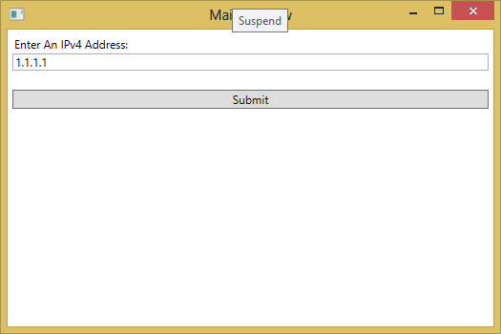
Figure 36 – Input Validation – Initial Screen

- Try to enter some value in the text box.
- You should see this kind of screen:

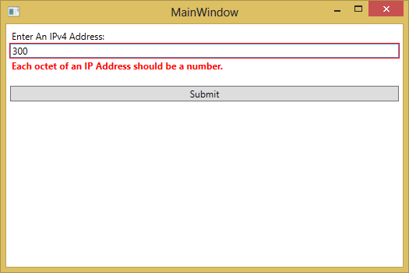
Figure 37 – Input Validation – Validation Message

      - Using Dialogs
We can also use the built-in .NET dialog boxes to show the validation messages, but instead of using the OnPropertyChanged event, we will use the Click event of the Submit button.
- From the previous sample, stop debugging.
- In MainWindow.xaml, replace the markup with this code block:

<Window x:Class="InputValidation.MainWindow"
xmlns="http://schemas.microsoft.com/winfx/2006/xaml/presentation"
xmlns:x="http://schemas.microsoft.com/winfx/2006/xaml"
xmlns:local="clr-namespace:InputValidation"
Title="MainWindow" Height="350" Width="525" Loaded="Window_Loaded">
<Window.Resources>
<local:ErrorsToMessageConverter x:Key="eToMConverter" />
</Window.Resources>
<StackPanel Margin="5">
<TextBlock Margin="2">Enter An IPv4 Address:</TextBlock>
<TextBox x:Name="AddressBox">
<TextBox.Text>
<Binding Path="IPAddress" UpdateSourceTrigger="PropertyChanged">
<Binding.ValidationRules>
<local:IP4ValidationRule x:Name="ValidationRule" />
</Binding.ValidationRules>
</Binding>
</TextBox.Text>
</TextBox>
<TextBlock Margin="2" Foreground="Red" FontWeight="Bold"
Text="{Binding ElementName=AddressBox, Path=(Validation.Errors), Converter={StaticResource eToMConverter}}" />
<Button Name="SubmitButton" Content="Submit" Click="SubmitButton_Click"/>
</StackPanel>
</Window>

- In the code behind of MainWindow class, insert this code:

using System;
using System.Collections.Generic;
using System.Linq;
using System.Text;
using System.Threading.Tasks;
using System.Windows;
using System.Windows.Controls;
using System.Windows.Data;
using System.Windows.Documents;
using System.Windows.Input;
using System.Windows.Media;
using System.Windows.Media.Imaging;
using System.Windows.Navigation;
using System.Windows.Shapes;
using System.Globalization;

namespace InputValidation
{
/// <summary>
/// Interaction logic for MainWindow.xaml
/// </summary>
public partial class MainWindow : Window
{
private string _ipAddress = "1.1.1.1";
public string IPAddress
{
get { return _ipAddress; }
set { _ipAddress = value; }
}

public MainWindow()
{
InitializeComponent();
}

private void Window_Loaded(object sender, RoutedEventArgs e)
{
this.DataContext = this;
}

private void SubmitButton_Click(object sender, RoutedEventArgs e)
{
ValidationResult validationResult = ValidationRule.Validate(AddressBox.Text, CultureInfo.CurrentCulture);

if (!validationResult.IsValid)
{
MessageBox.Show(validationResult.ErrorContent.ToString(), "Warning", MessageBoxButton.OK);
}
else
{
MessageBox.Show("Data is valid.", "Information", MessageBoxButton.OK);
}
}
}
}

- Save and run the application.
- Try to enter invalid IP address value.
- Click the Submit button.
- You should see this kind of screen:

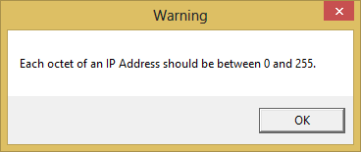
Figure 38 – Input Validation – Validation Dialog Message

In addition, we can also use the message dialog box as a confirmation request screen.
- In the code behind of MainWindow class, modify the SubmitButton_Click method into this block of code:

private void SubmitButton_Click(object sender, RoutedEventArgs e)
{
if (MessageBox.Show("Do you want to submit the data?", "Confirmation", MessageBoxButton.YesNo) == MessageBoxResult.Yes)
{
ValidationResult validationResult = ValidationRule.Validate(AddressBox.Text, CultureInfo.CurrentCulture);

if (!validationResult.IsValid)
{
MessageBox.Show(validationResult.ErrorContent.ToString(), "Warning", MessageBoxButton.OK);
}
else
{
MessageBox.Show("Data is valid.", "Information", MessageBoxButton.OK);
}
}
}

- Save and run the application.
- Click the Submit button.
- You should see this kind of screen:

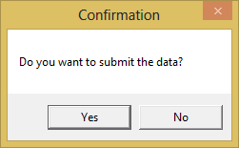
Figure 39 – Input Validation – Confirmation Dialog Message

    - Creating and Using Context Menu
Context Menus can be defined on any WPF controls by setting the ContextMenu property to an instance of a ContextMenu. The items of a context menu are normal MenuItems.
To start this section, follow these steps:
- Create a new WPF project.
- In the MainWindow.xaml file, insert this code block:

<Window x:Class="ContextMenu.MainWindow"
xmlns="http://schemas.microsoft.com/winfx/2006/xaml/presentation"
xmlns:x="http://schemas.microsoft.com/winfx/2006/xaml"
Title="MainWindow" Height="350" Width="525">
<Grid>
<TextBlock Text="Test" Width="400" Height="100">
<TextBlock.ContextMenu>
<ContextMenu>
<MenuItem Command="Cut">
</MenuItem>
<MenuItem Command="Copy">
</MenuItem>
<MenuItem Command="Paste">
</MenuItem>
</ContextMenu>
</TextBlock.ContextMenu>
</TextBlock>
</Grid>
</Window>

- Save and run the project.
- Right-click on the text box.
- You should see this kind of screen:

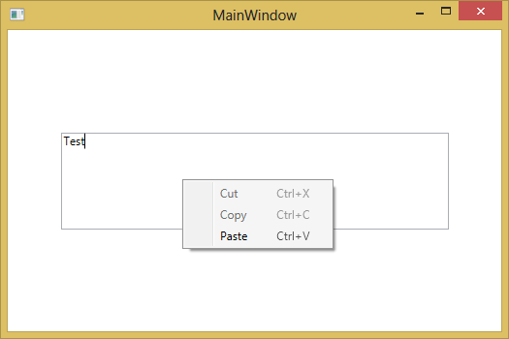
Figure 40 – Context Menu – TextBox With Context Menu

- Training Materials

These are the training materials needed for this learning offering:
- IntroductionToXAML.pdf
- Introduction to WPF Technology.pdf
- WPF Training Source Code.zip
The materials should be included along with this document for the sake of completeness.

http://www.wpfsharp.com/
http://dotnet-tricks.com/
http://en.wikipedia.org/wiki/Windows_Presentation_Foundation
http://wpftutorial.net/

